Centuries of Oppression - The Road to 1918
Last Update: 13/10/17

Contents
1. Introduction 2
2. The Medieval Period 4
3. The Era of Domestic Trades 7
4. Battles for Representation 10
5. The Industrial Revolution 13
6. Steam Power and Deaths at Work 17
7. The Chartists 19
8. The Great Reform Act 22
9. The Second and Third Reform Acts 24
10. From 1884 to 1918: The Overview 27
11. The Suffragettes, the Working Class and the Big Snag 29
12. The History of the Parliamentary Franchise in Numbers 32
13. The Parish and the Poor Law 35
14. Emmeline Pankhurst’s Errors and the Early Attempts at Female Enfranchisement, 1884 - 1914 39
15. The Hypocrisy of Emmeline and Christabel Pankhurst 47
16. The Great Unrest and Men’s Demands 51
17. The Constitutionalists and the Convergence on Democracy 55
18. The Speaker’s Conference and the Approach to 1918 61
19. Was the 1918 Act a Reward for Returning Heroes? 65
20. Was the 1918 Act a Result of the Suffragette Protests? 68
21. Why were women included in the 1918 Act? 69
22. Why the age limit of 30 in the 1918 Act? 71
23. Was the 1918 Act passed to avoid revolution? 73
24. If WW1 Had Not Happened, Would Universal Suffrage Have Occurred Anyway? 75
25. Summary and Conclusion 78

1. Introduction
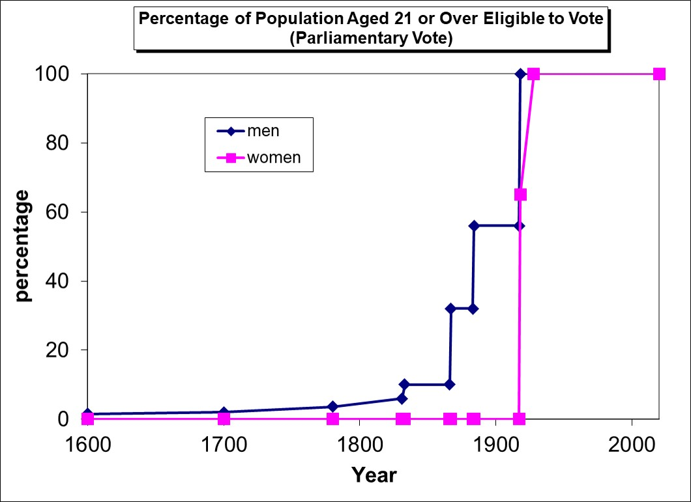
A centenary will be celebrated in the UK in February 2018. It very much deserves to be celebrated. It will be the centenary of an Act of Parliament, The Representation of the People Act 1918. This is the Act which gave the vote to the majority of women for the first time in the UK.
But this is not the only reason to celebrate – or even the most significant reason. The 1918 Act should be celebrated for something more fundamental. It should be celebrated for the triumph of democracy. Democracy in this context being understood as the right of all adult citizens to vote to elect their leaders. It has been forgotten that until that time, democracy in this egalitarian sense had been widely regarded as a radical, even subversive, idea.
The phrase ‘centuries of oppression’ is often used in the context of the situation before 1918. Well, if you must have a sound bite version of history, then ‘centuries of oppression’ might do as well as anything. But it was not oppression of women by men, as some now appear to believe. It was the oppression of the many by the few. And the many were of both sexes, and the few were of both sexes.
I have not conducted a poll but I feel fairly sure that to most people the phrase "universal suffrage" would be taken to mean "votes for women". The popular belief may be summarised as follows,
- Before the suffragette movement women did not have the vote;
- Before the suffragette movement men did have the vote;
- And, finally, that the suffragettes won the vote for women.
I will argue in this history that these three statements are, respectively: (i)not entirely true, (ii)grossly misleading, and, (iii)just plain wrong.
The history of universal suffrage is the history of the working class struggle, not just votes for women. Men, too, had to fight for the vote. In fact men had to literally, not only metaphorically, fight for the vote. Vast numbers of men died in the process. The suffragettes’ imprisonment and hunger strikes are well known. The huge numbers of men imprisoned, transported to penal colonies, killed in warfare or executed in pursuit of their parallel cause in earlier centuries is forgotten. And the role of WW1 in the final stages of the struggle largely unappreciated.
So the centenary of the Representation of the People Act 1918 should not only be celebrated as giving the vote to women. Whilst true, this is also seriously misleading. The Act should primarily be celebrated as having over-turned the class-based franchise and granted universal suffrage to both sexes. That the Act is now presented to us purely as "votes for women" says more about present day gender-political bias than it does about historical truth.
The history of universal suffrage tends to be presented to us now purely as a gender issue. But in reality there was little difference in the acquisition of universal suffrage by men and women when viewed on an historical timescale. And the triumph of women in winning the vote was absolutely dependent upon men having pioneered that democratic struggle. Nowhere is that more clear than in the suffragette era, though the truth of that period has been replaced in the public mind by myth.
Here I attempt to exorcise that myth and replace it with a more balanced account. I would say ‘true account’ were I not aware of how problematic that word is when applied to a complex history. For those who are emotionally wedded to the story of brave women triumphing over an hegemony of brutish, oppressive men, you will not like my version of events. But those who would prefer a story of men and women working mostly in harmony against a common class enemy will, I hope, like it rather better.
To start the tale of the rise of democracy in the suffragette era would be to open the book at the last chapter. In truth, the 1918 Act was the culmination of many centuries of struggle for fair representation; struggle, that is, mostly by men apart from the final few decades when women became more prominent. Just a few years before Victoria came to the throne, 96% of adult men still did not have the vote. And working men had already spent many centuries – intermittently - fighting for better conditions - including universal suffrage.
The last chapter the suffragette era may be, but it is that last chapter which has become most seriously misrepresented in the public mind. So it will be on the suffragette era that I will ultimately focus most attention. But not before spending a little time doing some measure of justice to the deeper history.

2. The Medieval Period
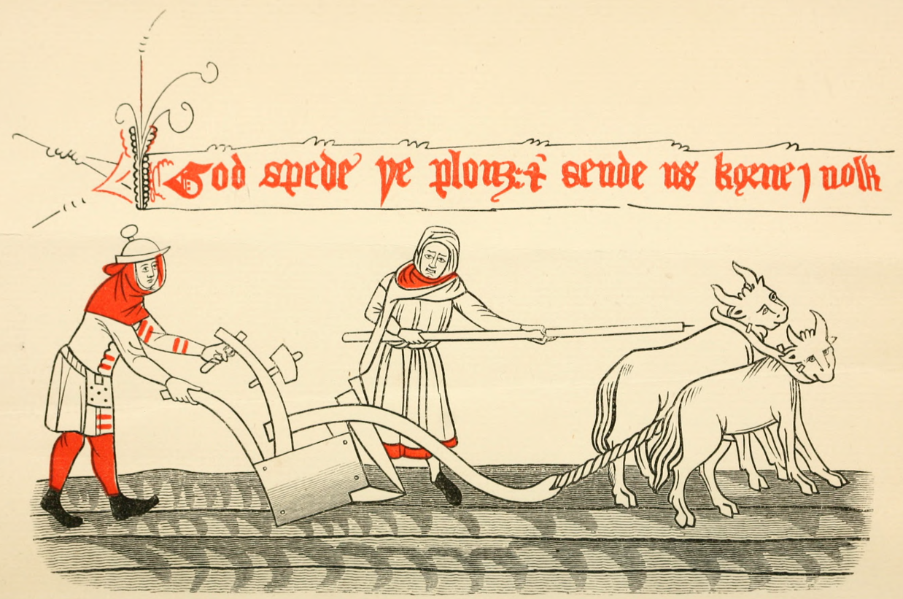
Piers Ploughman illustration
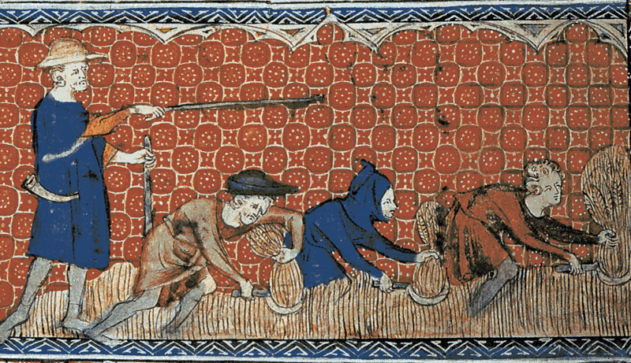
Reeve and Serfs harvesting
How far back need we go? Surely a thousand years will be enough. Conveniently, it is after 1066 that the written record starts to improve. Historical details of the intimate life of the common people is sparse, however. But let's start there (and concentrate on England).
We find that there were indeed centuries of oppression. History is the story of the struggle by the many to overcome tyranny by the few. In this struggle, men and women were as one. Both were in the same boat. The grinding poverty and incessant hard labour endured by most people were too overwhelming for internecine tensions, if any, to be of great significance.
These centuries of oppression were punctuated at intervals by uprisings of one sort or another, invariably led by men, sometimes more deadly than others, but always striving for justice for themselves and their families against the true hegemony - the landowning classes and their apparatchiks of State or Monarchy. Many of these uprisings or movements appeared to achieve nothing at the time. But over the centuries there were gradual gains. The greatest gains, though, occurred only when technology led to improving economic prosperity, notably in the nineteenth century. Finally, in the twentieth century, huge advances in technology created conditions in which the grinding poverty of earlier centuries became a rarity in England.
Life in post-conquest England was dominated by agriculture, controlled by the Manor. The feudal system reigned. Control of the land was presided over by the Lord of the Manor, who owed feudal fealty to his noble masters. 86% of the people, the villeins, cottagers and serfs, were not free. They were chattels of the Lord, legally bound to the Manor, they could not leave without permission. They could not even marry without permission of the Lord - and had to pay a 'fine' to do so. On death, the Lord took the deceased villein's best beast or chattel ("heriot"), and the Church took the second best ("mortuary"). Poverty was hereditary and inescapable. Villeins had to pay rent for the land they worked. They were also required to provide labour on the Lord's own land, the Home Farm, without pay. The obligation to work the Lord's land was their chief burden. In short, the majority of people were little better than slaves.
Today we are critical of third world countries whose populations have become embroiled in the production of cash crops for export, to their own detriment. This was the endemic practice in the feudal era. Whilst wheat was a common crop, you would not find fine wheaten bread on a villein's table. Hard, dark bread of oats or barley was their lot. Their protein was obtained largely from peas, beans, even acorns, and a few eggs. Meat was a luxury. This diet would not improve for many centuries to come.
It was inevitably a man who was "head of the household" because this position was defined by the necessity to provide labour, both to his own holding and that of his Lord. It would make little sense to place a woman in a position defined by the obligation to provide labour of which she was not physically capable. Thus, being "head of the household" represented an obligation, not a patriarchal privilege.
It is hard for the modern person to grasp just how grindingly hard was the life in medieval times. Oppression there was in spades under the feudal system. But it was not the common man oppressing his wife. Both were crushed together by feudal over-lordship.
A woman could not have survived alone in this rural economy. It was not mere social convention that forbade female independence. The sheer manual labour demanded by this primitive agriculture required male muscle. And agriculture was everything. On heavy soils a team of eight oxen in four yokes might be required to pull a plough. It is not for nothing that, for many generations, the phrase "holding plough" meant doing a man’s job.
The only thing worse than having an obligation to work the land was not having such an obligation, and therefore having no land to work. Such was the lot of serfs, who were abject slaves. The right to work a certain portion of land was hereditary. Since social status was predominantly defined by such rights, one's social status was generally also hereditary. A villein being bequeathed a right to work a parcel of land also inherited the linked obligation to provide labour on his Lordship's farm. This is why it was inevitably a man who inherited (primogeniture), unless there was no male heir, because what was inherited involved an obligation to provide labour.
The position of younger sons, who did not inherit, was essentially the same as that of daughters. Both might receive a portion of their father's goods and chattels on his death (after the Lord and the Church had taken their cut), but otherwise they would have to make their way separately, either through marriage or by lending their labour, or domestic service, to another household. Until a man had a holding of some sort he would not be able to support a wife and family, so custom dictated that he would not be able to marry (and recall that, as a non-free man, he could not do so without the Lord's permission). Many men, therefore, did not marry until their father died and they inherited. When feminists accuse men of having controlled their fertility in historical times, recall that, in truth, both men's and women's fertility were controlled indirectly by poverty and directly by their overlord. Recall also that, over deep genetic time, most men left no progeny whatsoever.
As a result of having to wait to inherit, men tended to be considerably older than their wives. As a result, widows were common. Where widows had inherited due to lack of a male heir, marrying a 'landed' widow would provide another route for a young man to obtain a holding, an arrangement benefitting both parties (because the widow would otherwise have needed to hire a man to fulfill her labour obligations).
To regard the common man as privileged, or exercising patriarchal hegemony, in such a system would be perverse to the point of delusion. There were no "fulfilling careers" for women to envy in this system.
Crushing though the economic circumstances of men were under feudalism, the chief yoke under which the villeins, cottagers and serfs toiled was being unfree. A struggle for emancipation was inevitable. The demand was to be freed from the degrading personal aspects of serfdom and the right to recognition as a full human being, not a chattel. Feminists might like to note just how fundamental was this struggle – this struggle predominantly by men - and how crucial it was to the later freedoms they now enjoy.
Before moving on from the feudal period, there are some linguistic phenomena which are very revealing. "Villein", of course, has become transmogrified into "villain" and hence come to mean someone wicked or criminal. "Naif" was synonymous with villein or serf, but has come to mean someone amusingly simple. And "boor" in Old English also simply meant "peasant", but now means a tedious or bad mannered person. It is interesting that the servile class, upon whom the economy of the country depended, have become denigrated linguistically. One might think they were more properly owed an apology, or thanks, rather than denigration. But denigration was ever the handmaiden of disadvantage. However, I digress.
Even under feudalism the unit of production was the household. Each freeman, villein or cottager was really a family business, aided by wife, sons, daughters and possibly hired hands if the headman's holding was large enough. From the twelfth century an increasing proportion of economic effort was contributed by the trades. These largely followed the same pattern: the dominant structure of such endeavours was basically domestic. Indeed, this would continue to be the case until the industrial revolution in the mid-eighteenth century.

3. The Era of Domestic Trades
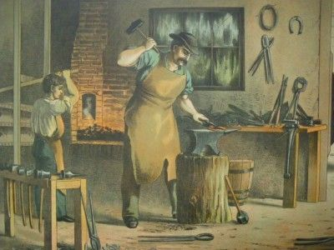
Blacksmith and Apprentice
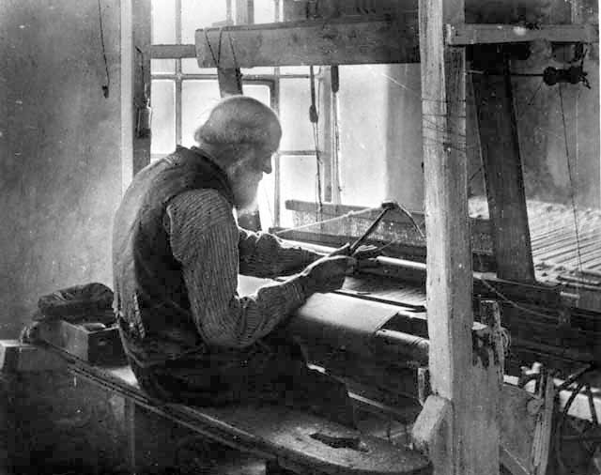
Handloom weaver
The trade guilds introduced the first elements of social security, recognising that the pursuance of a trade was a family business. The guilds enforced a structured apprenticeship system, and this took place within the master's house. Just as a feudal villein might be running a small family business, involving wife, sons, daughters, hired men and serving girls, so a town-based master tradesman would be operating a household business with the assistance of his wife and comprising not only their children, but also apprentices, journeymen and domestic servants - all housed in the master's house. And if the master was the Chief Executive Officer, his wife was the rest of the executive Board.
It is too little appreciated now that apprentices were not just apprenticed to the master. Because they were to live in the master's house, perhaps for seven years or more, in a situation of domestic subservience to the master's wife, an apprentice was indentured to both the master and the master's wife. Here is an extract from the indenture of one John Goffe to learn the craft of fishing, from 1459,
"The aforesaid John Goffe shall well and faithfully serve the aforesaid John Gibbs and Agnes his wife as his masters and lords, shall keep their secrets, shall everywhere willingly do their lawful and honorable commands, shall do his masters no injury nor see any injury done to them by others, but prevent the same as far as he can , shall not waste his masters' goods nor lend them to any man without his special command. And the aforesaid John Gibbs and Agnes his wife shall teach, train and inform or cause the aforesaid John Goffe, their apprentice, to be informed in the craft of fishing in the best way they know, chastising him duly and finding for the same John, their apprentice, food, clothing, linen and woollen, and shoes, sufficiently, as befits such an apprentice to be found, during the term aforesaid."
Whilst one might refer to such domestic trade arrangements as 'patriarchal' in the sense that the man was the accepted master of the trade and figurehead for the business, this can hardly be interpreted as an hegemony, still less as oppressive to the wife - who was second in command in such a business. Instead, it provided a means by which the wife could contribute substantially to their joint enterprise without compromising her ability to bear and raise children and direct all things domestic. The conflict between paid work and family duties, which features so prominently in modern gender politics, was avoided under these arrangements because the business was so inextricably linked to the domestic in any case.
I should not give the impression, however, that the trade guilds achieved a halcyon bliss of egalitarianism. Behind it all still lurked the power of the Monarchy, which could make itself felt at any time it wished. For example, despite the power of the Guild of Masons, when the king decided to build Windsor castle in 1360, he obtained the vast number of masons needed for the enterprise by the simple expedient of ordering press gangs throughout the land. It was not only the Navy which was staffed in this manner. And the ‘freedom’ of even notionally free trade’s men was not sacrosanct in the face of State power.
In 1300 the majority of people were servile; by 1500 only a few were still. Two events contributed significantly to this sweeping change: the Black Death and the Peasant's Revolt. One of the weaknesses of depending upon a servile class is that the master is, in a sense, a slave to the servant. Feudal Lords were entirely dependent upon their villeins' labour. This gave the Lords the whip hand when people were plentiful. But between the mid-fourteenth and mid-fifteenth centuries the Black Death reduced the UK population to less than half. The balance of power changed - or, at least, the peasantry now had some power - those that survived.
Now labour was scarce the people could demand higher wages, both artisans and agricultural workers. The State responded by passing legislation to define pay rates and other terms of employment. But the landowning class was to learn a lesson in supply and demand - which could not be defeated by Statutes. Agricultural workers would up sticks and move to another area if their demands were not met, whether the landowners approved or not. For some this might technically make them outlaws. It may be no coincidence that it was about this time that the legend of Robin Hood arose.
The matter was brought to a head by the English kings' insistence on pursuing a cripplingly expensive war with France, funding the same with successive waves of taxation. At this point the Peasants truly did become Revolting. Enter Wat Tyler, John Ball, Jack Straw, et al. But we'll not go there, fascinating though it all was. The message is simply this: freedom was in the air; the people's political consciousness had been raised.
The message for feminists is that history is the story of the struggle of the mass of common people for better conditions of life. Men and women were as one in this, though it was men who led when things turned nasty. But the battles were waged for the benefit of the whole family against the landowning classes.

4. Battles for Representation

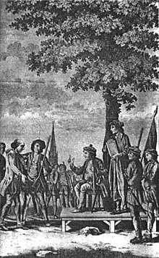
A group of dissenters in Norfolk during Robert Kett's rebellion of 1549
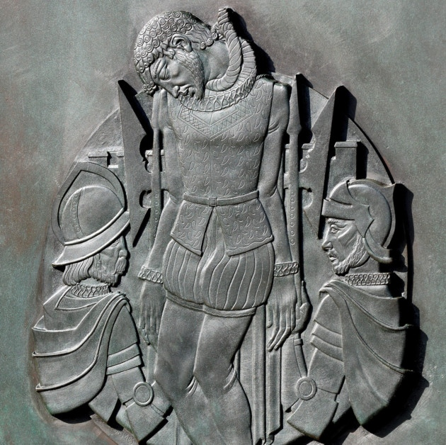
The end of Kett, leader of the rebellion put down at the Battle of Dussindale 1549
Who knows how many minor skirmishes there were between the peasant and landowning classes in the 14th, 15th and 16th centuries. One particularly significant movement started in 1549 near Norwich. By then, with the help of educated men, the peasants were able to draw up lists of grievances to be addressed. And by this time a religious tone was beginning to enter their rebelliousness. Here are just a couple of the 29 articles which the peasants were demanding,
We pray that all bond men shall be made free, for God made all free with his precious blood-shedding.
We pray that no person, of what estate, degree or condition he be, shall from henceforth sell the wardship of any child, but that the same child, if he live to his full age, shall be at his own chosen concerning his marriage.
This peasant uprising was initially met with a force of 1400 soldiers, but the soldiers were defeated. Then the Earl of Warwick threw 12,000 English troops plus 1,200 German mercenaries at them and the peasants were slaughtered at the battle of Dussindale. Some 3000 peasants were killed. At least fifty more were subsequently executed for treason.
This is just one illustration out of many of the price paid - invariably by men - for the incremental approach to the freedoms we now enjoy. As for universal suffrage...consider Cromwellian times,
Perhaps emboldened by their defeat of the Monarchy, some members of Cromwell's parliamentary army had the temerity to support calls for universal (male) suffrage. What cheek - in 1647! These were The Levellers. Their significance lies in their attempt rather than their success, continuing the struggle begun by the fourteenth century peasants' revolt and continued by the Dussindale martyrs, but becoming bolder still in their demands. Perhaps their greatest significance lay in their continuance of the theme of increasing political awareness. To quote Harrison,
"The Levellers subscribed to a simple labour theory based on the natural right of every man to the fruits of his own labour; with the corollary that to take it away was theft....They scorned and resented the classes above them who did not work but who arranged the world for their own convenience and profit....They wanted an effective say in the making of decisions which closely affected them, and they saw that they would never achieve that without political power. Hence their concern for democratic government at the local and national levels."
Obviously radical nutjobs! The Levellers had a theory that, because all their woes were caused by the landowning nobles, their troubles all originated with William the Conqueror, or William the Bastard as they called him, who installed his Normans as Lords throughout the land. There are some who think that is still the case today.
None of The Levellers' demands were met in their own day, and their practical achievements were negligible. Ostensibly, much the same can be said of the Chartists in the nineteenth century. And yet would greater democracy and freedom have ever been achieved without earlier unsuccessful attempts? Who knows.
Villeinage finally came to an end with the 1601 Poor Law, an Act which applied until the Victorian era and transformed provision of poor relief. Each parish was made responsible for its own poor relief, funded by local rates and administered by locally elected officials (many of whom were women, as we shall see shortly).
For all the revolting peasants and reforms, through the sixteenth and seventeenth centuries it was still only an extremely tiny minority who owned virtually everything. A remarkable survey of the wealth of the nation was carried out by Gregory King in 1688. This revealed that the majority of people were in poverty, in the sense that their annual expenditure exceeded their income - so were presumably receiving some degree of poor relief or charity. King's survey was based around the family, confirming this remained the unit considered most appropriate for economic purposes. However, ‘family’, in this context, meant ‘household’, and so might include servants or other subservient people. England was considered to comprise 1,350,000 families, or 5.5 million individuals. Although 110,000 families were classified as shopkeepers, artisans, tradesmen or craftsmen, it was still agriculture that accounted for three-quarters of people's occupations.
The conditions for apprentices in the trades had, by the early eighteenth century, changed little from those of the fourteenth century. Harrison records an account by one William Hutton of his apprenticeship with a weaver between 1737 and 1744. In truth, few trades truly required seven years to learn. But the apprentice received little or no remuneration. So, once he was proficient, he would spend the later years of his apprenticeship being as productive as his master, and hence earning well for his master but little or nothing for himself. Harrison notes, "The master's wife still figured large in an apprentice's life. Hutton's master's wife was dominant, hypocritical and mean, and grudged him every bit of food he ate: 'It was considered by the mistress almost a sin to eat". The Hutton family was not blessed with supportive wives. His father died following six years of agony from "bladder stones, severe poverty and the greater severity of a cruel wife". At the completion of his apprenticeship Hutton asked his master if he could set up a 'frame' (a weaving loom) in his room, paying as appropriate, in order to qualify himself as master. His master cheerfully agreed, only to be over-ruled later by his wife. There is plenty of evidence here that women were anything but doormats. Harrison notes that,"Hutton's autobiography serves to remind us of the centrality of the family as a social unit. The extent to which everyday living and working were dependent upon family relationships comes out clearly in its pages.”

5. The Industrial Revolution
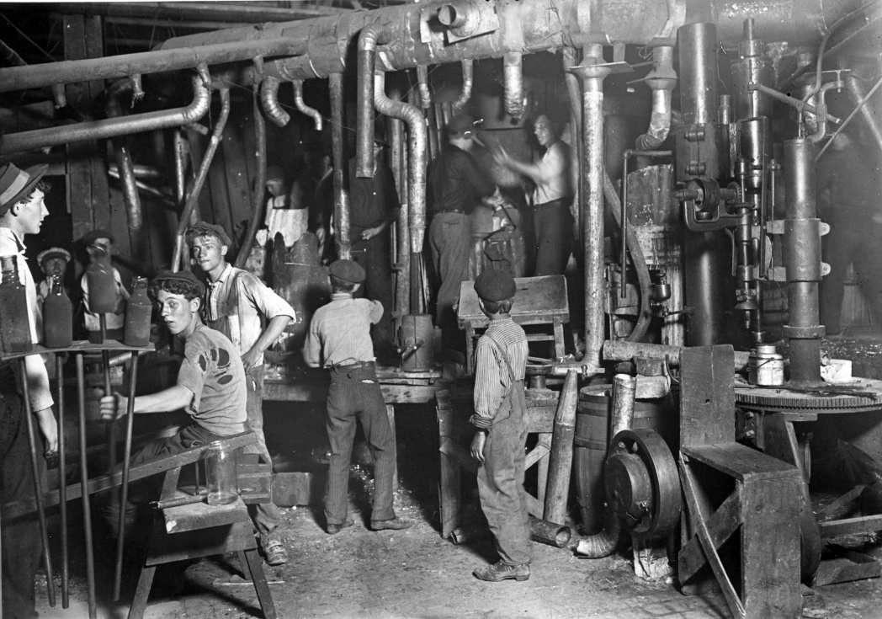
Child factory workers in the industrial revolution
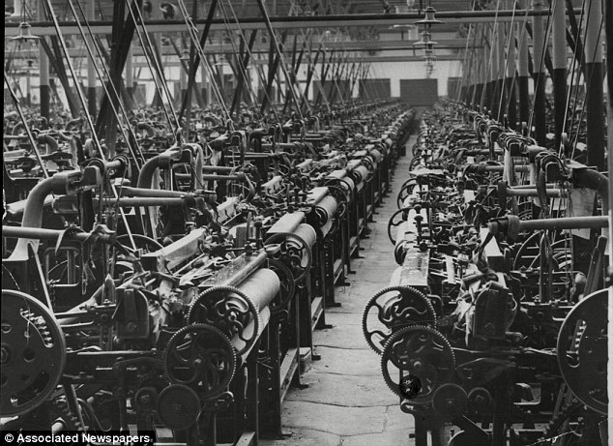
Industrial revolution – a cotton mill
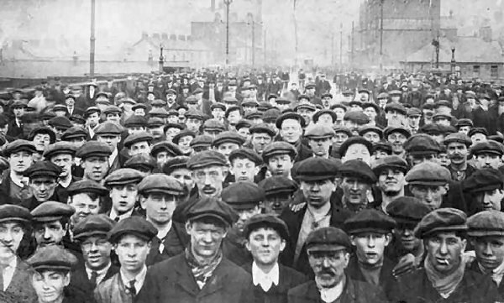
Workers pouring out of a factory
The industrial revolution of the late eighteenth and early nineteenth centuries has been credited with the most significant social change since the Neolithic. Rightly so, for it broke family-based industry which had been the norm hitherto, both in town and country. As such one can trace the beginnings of the estrangement of fathers from the family to this event. Prior to this, men’s work, whether agricultural or in trade, had been centred around the family home. For the first time, men would be required to spend their whole working day away from home and family.
The modern tendency is to criticise men for lack of flexibility. Working men, it is said, have had trouble coping with the disappearance of ‘traditional’ working men’s jobs. But by ‘traditional’ is meant factory work, which, taking a rather longer historical timescale is not traditional at all, but a recent innovation. And men had to adapt to this innovation from the earlier domestically based employments. In truth it is inevitably men who bear the brunt of changes in working practices, because it is men whose whole raison d'être is resource provision via work. Whatever your ideological opinion may be as to any more desirable state of affairs, this is an historical fact. Women, in contrast, have always had an unchallengeable role in the domestic sphere, especially as regards children.
By the industrial revolution, the population of England was several times larger than it had been, say, at the time of the civil war. And the rise of factory-based industry drove the rise of the towns and cities, causing mass migration from the countryside. In the mid-eighteenth century, barely a quarter of the adult population of Manchester, Glasgow, Bradford and Liverpool had been born there. Despite these mass migrations, the hunger of the giant mills for workers resulted in widespread child labour - slave labour, in truth - often taking pauper children from the workhouses of London for the purpose.
Feudal landowners had been replaced by mill owners, the main difference being that their wealth was not always hereditary. Conditions for factory workers were notoriously harsh. The working day would start at five am and not end until 7 pm at the earliest. Some reports of the treatment of 10 year old 'apprentice' boys, ex-workhouse, had them working as late as 9 or 10 pm, having had just one lunch break in a 16 hour working day.
Is the most significant feature of this time "patriarchal oppression", do you think? Only if the patriarch in question was the mill owner, I suggest.
It should be apparent from the preceding accounts that women and children had always, from feudal times onwards, contributed to the remunerated work, albeit subsidiary to men. This became even more the case under the factory system. Whilst the working unit was no longer the family, the earning unit was still - for a man's wage alone would not be sufficient. As powerlooms took over in the cotton mills, it required no great strength nor any great trade skill to operate them. Consequently, it was women who were employed as powerloom operators. Those whom they put out of work were the skilled hand-loom weavers - men. As Harrison puts it, "The plight of the weavers was a vivid illustration of how helpless a section of labouring men could be when caught between the relics of the domesticated system and the full force of competitive industrial capitalism". You might be tempted to translate that to the present day: how helpless a section of labouring men might be if caught between the relics of the industrial era and the post-industrial modern world. Presuming an obligation on men to be the principal provider, it is inevitable that men must be most vulnerable to change in working pracices. The highest earners are necessarily most at risk from employers' economies.
The increasing population, together with the decreasing proportion of the population involved in food production, could be supported only by greater agricultural efficiencies. This came in the form of enclosures of former common or waste land for cultivation, and consolidation of small holdings into better managed farms. Essentially this was capitalism of the countryside, rewarding the enterprising but leaving the less able, or less lucky, in pauperism. Both in the town and the country there was increasing pressure on poor relief - still funded locally by parish rate-payers. As the pips began to squeak, reform of the old 1601 Poor Law led to the building of the Workhouses, places which were deliberately made grim as a deterrent. More of that later.
Unsurprisingly, working conditions led to a sequence of protest movements in the early nineteenth century. Infamously there was the Peterloo massacre in Manchester (1819). Some 60,000 men and women had gathered to hear a speech as the culmination of a reformist campaign. It was entirely peaceable - until the yeomanry's attempt to arrest the speaker led to them charging the crowd with sabres swinging. Over 400 people were injured and 11 killed.
The Luddites, famous for their 'unprogressive' attitude towards factory machinery, were in many cases actually protesting for better pay, rather than to remove the machines. The machine smashing was simply their form of protest. Similarly, the demands of 'Captain Swing' were mostly around pay, and also threatened machine breaking and other violence. But the 'Swing' riots began following some terrible treatment of those on poor relief, including the harnessing of men - and women - to carts, and the discovery of harvest labourers starved to death in a ditch. Nearly 2000 Swing rioters were brought to trial in 1830/31. 252 were sentenced to death, 481 were deported to penal colonies in Australia, and 644 were imprisoned. They were overwhelmingly men, many young married men whose execution or deportation left families destitute. This draconian treatment was meted out despite no one, other than one rioter, having been killed in the riots.
I invite you to contemplate how apposite is the feminists' "patriarchal oppression of women by men" perspective of history when the dominant theme is actually male struggle against the true oppressors? And why is it that left-leaning people today, no doubt weaned on the events described here, have become so keen to back feminist distortions and so confused about their own history?
With the industrial revolution came the rise of the middle class, or bourgeoisie. In gender politics this is crucial, because it is in respect of women that class distinctions are most emphatic. Whilst the mill owner could hardly be compared with his workers, he was, at least, involved in running his business. The hallmark of the middle class wife, on the other hand, was complete disassociation from the world of work and public affairs. At this point one might be tempted to refer to it as "the male world of work", but, of course, it wasn't. The mills were full of women. And women had, as we have seen, been closely involved in remunerated work all along. From the feudal system and domestically based trades through to the industrial era, women (and children) had worked alongside men. Sure women's working years, and hours, were constrained by childbirth and childcare, and also limited to areas not requiring great physical strength. Nevertheless, in 1850 to 1900, 30% of the workforce were women (the largest number being in domestic service). The perception that "men did paid work, women did not" was never the correct story for the working class. And the perception that "men went to work, women stayed at home" was only the norm for middle class woman, the bourgeoisie.
Whether women's historical involvement in the workplace was a great boon to them is another matter. It wasn't, of course. It was economic necessity. The feminists insist that work is liberation, because financial independence means - well, freedom from a nasty abusive man is the implication. But what nonsense this is when placed up against historical reality. Working class women could not have survived, financially, on their own at any time before the twentieth century. Once children enter the picture, even most working class men could not earn enough to support a family - until the twentieth century. Even in the 1930s the lot of unmarried men was worse than that of married men – read The Road to Wigan Pier. The picture of life against which feminists rail had barely existed before the 1950s, and by then the working class was beginning to enjoy ever greater prosperity.

6. Steam Power and Deaths at Work
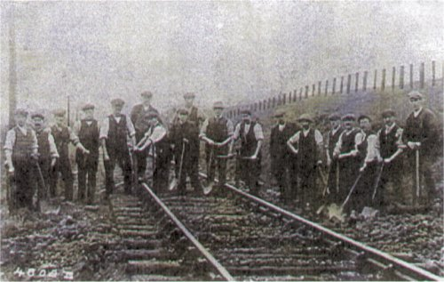
Some of the navvies who died building the West Highland railway
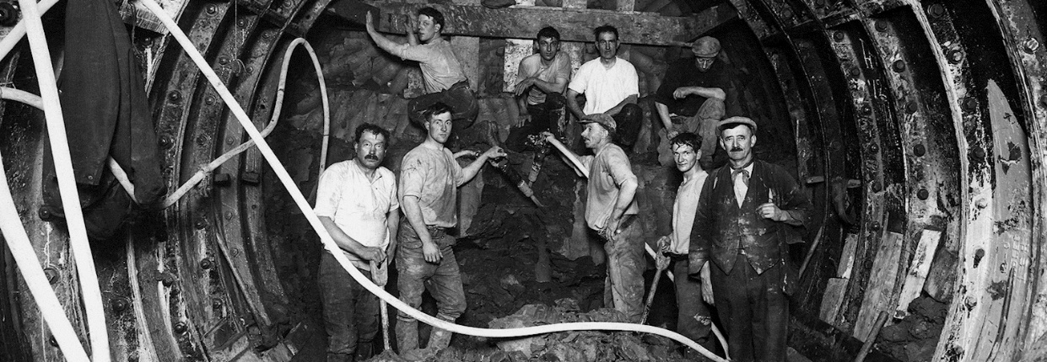
Navvies working on constructing the London underground
Work which attracted a man’s wage continued to be overwhelmingly hard labour until after WW2. Whilst the trade union movement had some influence in improving working conditions for such labouring men from the late nineteenth century, it wasn’t until after WW2 that anything approaching modern health & safety at work came about. In particular, the conditions under which many working men toiled remained truly appalling throughout the industrial revolution and the Victorian era and beyond. These were the men, recall, that did not have the vote.
As an example, consider the British canal system. This underwent a huge expansion during the industrial revolution due to the demand for industrial transport. It was, therefore, a key component in Britain’s improving economic strength between roughly 1770 and 1830. During this period some 4,000 miles of canals were dug by hand by men with picks and shovels. These were the Navvies. They would later dwarf that mileage of canals by an even more prodigious mileage of railways.
The public imagine the typical Navvy to be Irish. Certainly many were, but the majority were indigenous. Many were agricultural labourers from neighbouring counties or former hand loom weavers who had been rendered unemployed by the march of the machine looms in the industrial revolution. The work was appallingly hard, but employment prospects were good. No sooner had the golden age of canal building finished than the golden age of railway building began, the same Navvies – those who survived – transferring from one means of transport construction to the other.
The Victorian era saw Britain master steam power before the rest of the world. Whilst steam power predates the Victorian and was one of the driving forces of the industrial revolution, it was during the Victorian period that the technology was put to widespread application, including on the railways. This mastery of steam power, and associated engineering, was instrumental in Britain’s burgeoning fortunes over that period, both economic and political. Steam power required coal, and steam power gave rise to the railways. Miners and Navvies were in great demand – grim though the work was.
Between 1850 and 1914 some 90,000 men died in British coal mines.
Between 1822 and the end of that century, Navvies built 20,000 miles of railroad by hand, including many cuttings, embankments, viaducts and tunnels. There was no machine assistance to speak of, though gunpowder was used in places. Whilst steam shovels existed, men were cheaper. There were quarter of a million Navvies employed at the apex of the British railway expansion. Given that the working life of a Navvy was not over long, the entire span of canal and railway building from 1770 or so to around 1900 must have involved roughly a million Navvies.
Navvies did not live to be old. In any case, few men over 40 would have been up to the prodigiously hard labour. Their squalid living conditions, poor diet and heavy drinking contributed to their short life. But enormous numbers were killed on the job. Particularly hazardous tasks attracted a small bonus and that was enough for men to volunteer despite the known dangers. No compensation for worker deaths or injuries were payable at the time, so the companies which hired the Navvies had scant reason for encouraging safety. Being drunk at work was no doubt an added cause of avoidable deaths, though it is difficult to lay the blame entirely on the Navvies. Some companies insisted on payment partly in beer. And it was generally the case that wages were paid in, or next to, a public house – conveniently owned by the railway company.
As far as I have been able to discover, no one has an accurate figure for the numbers of Navvies who died constructing Britain’s canals and railways. There are, however, plenty of examples of numbers of deaths constructing specific tunnels, viaducts or stretches of line. One of the most scandalous was the construction of the first Woodhead railway tunnel. At just over 3 miles, the Woodhead tunnel was one of the world's longest railway tunnels when it opened in 1845. 32 men died of the 400 men employed in the excavation and lining . The death rate among the Navvies who built the tunnel (8%) was said to be higher than that of the soldiers who fought at the battle of Waterloo. However, it has been estimated that around 200 navvies died constructing the Ribblehead viaduct, on which some 2,000 men were working at its height – which is a higher death rate still (10%). It is unlikely that the death rate was as high as these examples in all cases, but it is likely that of the million or so Navvies who contributed to Britain’s canal and railway systems, the order of tens of thousands were killed on the job.
Premature death is a male speciality, and not always through rashness as some would have you believe. The idea of male disposability is more than just a theory: it is a demonstrable facet of history. And if this discussion of deaths at work has seemed like a distraction from my theme, namely obtaining the vote, recall that working conditions – and the conditions of life generally – were the reason for the common people being interested in obtaining the vote. The common man – and very close behind, the common woman – were beginning to appreciate that improving their conditions of life required political influence. Finally, the age of successful suffrage campaigns had begun - though it would start with famous failures.

7. The Chartists
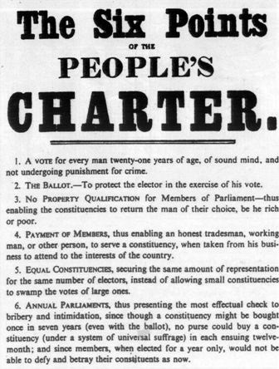
The People’s Charter
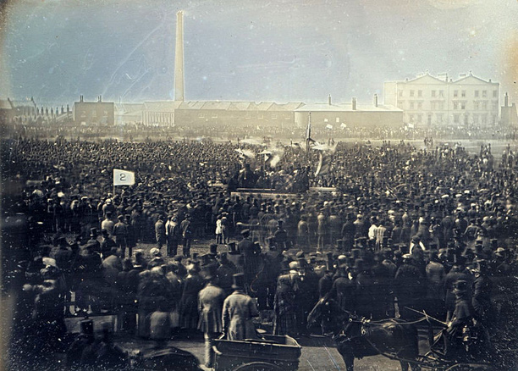
The Great Chartist Convention, Kennington Common, 10th April 1848
The suffragettes did not invent campaigning for suffrage. In addition to the various peasant uprisings of earlier centuries, working men's movements had campaigned for the right to vote since the end of the 18th century. In contrast to the Swing rioters and Peterloo victims, the famous Tolpuddle martyrs of 1834
were insignificant in number, just six, but significant in regard to the growing political awareness. They were transported for the crime of forming a trade union. Their bible was Thomas Paine's Rights of Man, and they called for universal male suffrage. Enter the Chartist movement, the first truly mass movement of the common people with primarily political objectives.
The Chartists were disparate groups of men agitating to be enfranchised and active in the early Victorian era. The main policy of the Chartists was to achieve universal male suffrage. In their early days, they were so radical as to propose universal suffrage for both sexes, but quickly retrenched on the grounds that votes for women was rather too great a stretch. In the end, of course, universal male suffrage was barely achieved before that of women, as we shall see.
The Chartist’s principal objective was votes for all men over 21 and a secret ballot. They also called for any man to be eligible to stand for Parliament and for MPs to be paid so as to enable working men to take up the post. These demands were put in the form of a People's Charter, giving the movement its name.
The Chartists rather lacked cohesion in their early years. From the start there was tension between those advocating physical force and those who were against it. However, the Chartists became better organised than earlier working class political movements.
The depression of 1841–1842 led to a wave of strikes in which Chartist activists were in the forefront, and demands for the Charter were included alongside economic demands. Hundreds of Chartists were arrested and either imprisoned or transported to Australia. In 1848 the Chartists organised a mass meeting on Kennington Common attended by ~150,000 people, a testament to the extent of their popular support. The government was nervous about the revolutionary precedents being set in Europe in 1848, as they would be again in 1917. Accordingly, the Chartist's convention was met by an emphatic display of the establishment's power in the form of 100,000 special constables recruited specifically to bolster the police force. In the event the meeting was peaceful. But emergency planning had extended to the military standing by in case the Chartists made any attempt to cross the Thames.
Their high point was a three-and-a-half million signature petition in favour of their People's Charter which was presented to Parliament in 1842. It took several cabs to transport to Downing Street. The movement was also organised enough to have its own newspapers, such as The Northern Star which ran the following article in May 1842 after the petition had been rejected by Parliament:
"Three and a half millions have quietly, orderly, soberly, peaceably but firmly asked of their rulers to do justice; and their rulers have turned a deaf ear to that protest. Three and a half millions of people have asked permission to detail their wrongs, and enforce their claims for RIGHT, and the 'House' has resolved they should not be heard! Three and a half millions of the slave-class have holden out the olive branch of peace to the enfranchised and privileged classes and sought for a firm and compact union, on the principle of EQUALITY BEFORE THE LAW; and the enfranchised and privileged have refused to enter into a treaty! The same class is to be a slave class still. The mark and brand of inferiority is not to be removed. The assumption of inferiority is still to be maintained. The people are not to be free."
The failure of the Chartists left the proportion of adult men who had the parliamentary vote at around 10%. The sacrifice of a mere few hundred men by the Chartists was insufficient. It would take the deaths of millions in World War 1 to finally buy the working class vote.
Despite its failure, the Chartist movement raised working class political consciousness - and also provided a model of how the working class could be organised politically. Arguably this provided the model for the later rise of the Trade Unions and the Labour movement.
In the second half of the 19th century the Chartist movement gradually gave way to the trade union movement as a voice for the working class. The Chartist movement was in some ways the male equivalent of the suffragette protests, but the working class Chartists attracted a far larger number of active participants.

8. The Great Reform Act
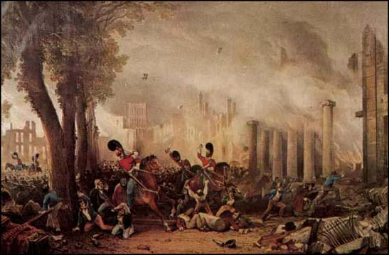
3rd Dragoon Guards suppress the 1831 Bristol riots
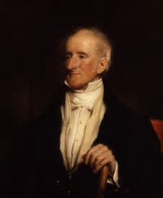
Sir Francis Burdett
The Great Reform Act was not so great as regards the working man – or woman. But its intention was not primarily to extend the franchise. Its purpose was to correct flagrant partisanship inherent in the system for electing Members of Parliament. Most members nominally represented boroughs. But the number of electors in a borough varied widely, in some cases being merely a handful of people (so-called “rotten boroughs”). It was common for the selection of MPs to be controlled by one powerful patron. Moreover, a single rich patron may effectively control multiple boroughs – up to 11 was known. These were known as “pocket boroughs”, because they were in the pocket of the patron.
In the hundred years before the Great Reform Act, one-quarter of all the constituencies of England and Wales had had either no election or just one election. In those days, many elections were uncontested. The ruling classes effectively decided amongst themselves who would take a seat. The system was completely rotten.
Thus, the limited intent of the 1832 Act was to clean up the more rotten aspects of the electoral process. This limited scope was in spite of popular unrest and radical calls for universal suffrage, even as early as the 1810s, during which decade there was serious economic hardship.
The Bill travelled a rocky road. So rocky, in fact, that three Bills were required before it was enacted. Failure of the first attempt in 1830 led to the dissolution of Parliament and a general election. The second Bill passed the Commons in 1831 but bombed in the House of Lords (largely due to the Bishops, incidentally). This failure of the second Bill led to serious rioting in Nottingham and Bristol. In Bristol the rioters took control of the city for 3 days. The third incarnation of the Bill received Royal Assent in 1832. How long the rioters may have been pacified by this I don’t know, but in truth the Great Reform Act probably led to fewer working class men having the vote, rather than more. The beneficiaries were the emerging middle class.
The motivations of MPs for bringing the 1832 Bill were complicated, to put it mildly - but democracy was not one of them. The British establishment had never recovered from the shock of the French revolution, and the fear of contagion spreading to England remained even at this period. The frequent working class riots added to the concern, as did the increasing unrest in Ireland. This was, no doubt, why the Swing rioters were punished so harshly. Historians can argue amongst themselves whether Britain really was in danger of revolution prior to the Great Reform Act. But enough of the people that mattered in 1832 believed it - so the Bill was passed.

If that all sounds like a bit of a damp squib as far as the working man was concerned…well, not entirely. You can date the start of the decline of the power of the Monarch, the aristocracy and the House of Lords from that Act. So ultimately it worked for democracy, even though that wasn't so apparent at the time. Most MPs didn't think of democracy as a desirable objective in those days. Parliament would have been more concerned about maintaining order and upholding property rights.
"Democracy" was a dirty word, fit only for the mouths of radicals.

To illustrate how far Parliament was from an egalitarian mindet, consider what happened when Sir Francis Burdett, in1809, proposed a resolution in favour of universal suffrage, equally sized electoral districts, and voting by secret ballot to the House of Commons. His motion found only one other supporter (Lord Cochrane) in the entire House.

And what about female suffrage? John Stuart Mill’s famous polemic of 1861-69, The Subjection of Women, is usually taken as the start of the serious women’s suffrage movement. However, Jeremy Bentham had argued for female suffrage as early as 1817, and others shared his view well before John Stuart Mill. It is noteworthy, then, that women’s suffrage was surfacing as a political issue when only 4% of adult men had the vote. The Great Reform Act itself was a blow to women, though, because it explicitly referred to ‘male persons’. Interestingly, this was the first explicit statutory bar to women voting. More of that later.

9. The Second and Third Reform Acts
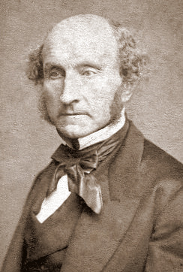
John Stuart Mill – campaigned for the enfranchisement of women when still only 10% of men had the vote
The working class were not fooled for long regarding the failure of the Great Reform Act to address their concerns. This, together with the 1834 Poor Law Amendment Act, which introduced the deliberately hateful Workhouses, is what prompted the popular Chartist movement.
In the context of the motivation for the second Reform Act of 1867, a Parliamentary site states, “the Chartist Movement had peaked by the 1850s but there was an acceptance among Members of Parliament that there was more work to be done to remove anomalies in the system that the first Reform Act had not addressed”. This gives the impression that Parliament was responding to the will of the people. I feel this is slightly disingenuous, though I would agree that the Victorians, for all their failings, did at least believe in rewarding contribution to the national good. There was a growing recognition by the political elite that the national wealth was increasingly dependent upon a new type of technological citizen, both of middle class and proletariat varieties.
The Victorian era saw huge advances in science and technology. Don't let anyone tell you that the British empire was won on the playing fields of Eton. It was far more to do with British mastery of steam power before anyone else and British engineering skill. Moreover, the great industrial cities were rapidly becoming the dominant economic forces in the land. At the Great Exhibition of 1851, half the exhibits came from Britain. The agricultural and rural lobby, including landed aristocrats, whose patronage had held sway over parliament for centuries, were no longer the dominant powers.
So, in part, the second Reform Act was a response to the political rise of the nouveau riche mill owners. But, perhaps more important was the rise of what became known as the 'labour aristocracy'. These were the skilled men that the country increasingly depended upon. Not just anyone could maintain the steam engine which drove a factory, still fewer could make one in the first place.
For a possible sub-text to the actions of Parliament, recall that it was, in part, fear of revolt following the French revolution and civil riots at home which formed the background the Great Reform Act. That being so, was the second Reform Act of 1867something to do with the American Civil War (1861-65)? The timing is suspicious. As Lang puts it, “There were more than enough examples of recent violent political uprisings, from Garibaldi’s successful invasion of Sicily to the American Civil War, to lend credence to fears of the consequences of entrenched opposition to the will of the people”.
We will see later that the 1918 Representation of the People Act, whose deep history I am addressing, followed the 1917 Russian revolutions. Coincidence? Possibly. I merely note that there is a strange consilience between major revolutions abroad and electoral reforms in the UK.
What certainly did not underlie the second Reform Act is sympathy for the idea of democracy. In the mid-Victorian period, democracy was still a dangerously radical notion. But the old emphasis on maintaining entrenched privilege had given way to a more egalitarian idea that, whilst the vote was not seen as a right, it was something that could be earned.
In the context of the 1867 Act, the same Parliamentary site quoted above states, “there was no question of campaigning for the right to vote for women too”. That is poorly phrased. There certainly was a “question of campaigning for the vote for women”. John Stuart Mill did just that with The Subjection of Women, the arguments of which he deployed in Parliamentary debates leading to the 1867 Act. Stuart Mill had been elected MP for the City of Westminster two years earlier on a platform including votes for women. So, the women's cause was very much in the ascendency at or before the second Reform Act.
It's worth recalling that when John Stuart Mill started to raise the cause of women’s suffrage, still only about 10% or 12% of adult men had the vote - and the very concept that democracy might be a good thing was still some way in the future - including for men. This illustrates that the more impenetrable political barrier was the enfranchisement of the working class – that is, the adoption of democracy – not the enfranchisement of women per se. This is a theme that will be repeated later in the suffragette era.
A quote from Disraeli from his speech proposing the 1867 Act makes the establishment distain for democracy abundantly clear, “we do not live – and I trust it will never be the fate of this country to live – under a democracy. The propositions which I am going to make tonight certainly have no tendency in that direction”.
Can you imagine an MP today proposing a Bill with an assurance that it would be absolutely uncontaminated by anything so vile as democracy.
Nor had democracy stopped being a dirty word by the third Reform Act. Even in 1884, leading politicians still regarded democracy as a dangerous tendency. The third Reform Act, 1884, was essentially more of the same. More working class men got the vote, but the franchise was still household-based and excluded nearly half of men.
So, after all the hoo-hah and three Reform Acts, had there been no great change?
No, that's absolutely untrue. Even though democracy was still not an accepted principle by 1884, inroads had been made into the previous self-perpetuating vested interests and the scene was set for the eventual triumph of democracy in 1918. At the risk of stating the obvious, you can find some stupendously silly commentary on the internet, such as this,
"Political changes were very slow in coming from 1750 to 1900. Those that did come in 1832 and 1867 were seen as not changing a great deal especially as neither gave women the right to vote."
This fatuous remark dismisses all three Reform Acts as unimportant on the grounds that they did not give the vote to women. But these Acts increased the male franchise from about 4% of the adult male population to 56%, hardly an insignificant matter. And hardly insignificant even if your whole focus is on women, because, without men pioneering a broader franchise, the ground would not have been prepared for women to do so later. It is a fine illustration of how the feminist mind-set fails to appreciate that the fates of men and women are linked. The same phenomenon of man-blindness blinkered the suffragettes and many of their contemporary female suffragists to the true obstacle in the way of their own enfranchisement: that of working class men. But I get ahead of myself.
In summary, the three Reform Acts of 1832, 1867 and 1884 respectively resulted in the proportion of adult men over 21 who had the vote increasing from about 4% to around 10% then to 32% then to 56%. And that’s how it stayed until near the end of WW1.

10. From 1884 to 1918: The Overview
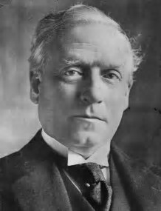
Herbert Henry Asquith, Liberal Prime Minister 1908 - 1916
The salient facts over this period were that, whilst women were yet to achieve the Parliamentary vote at all, only about half of adult men had the vote either. This period, especially in its later half, was the era of the suffragette. “It was in 1903…..We voted”, wrote Emmeline Pankhurst, “to call our new society the Women’s Social and Political Union (the WSPU)…….We resolved to limit our membership exclusively to women”.
The suffragettes, typified by the WSPU, and led by Emmeline and Christabel Pankhurst, are the ones whom history has mostly remembered. They were the ones who indulged in what we would now call direct action – or even terrorism - including violence, bombing and arson.
The prominence of the suffragettes in the public imagination has led to an incorrect understanding of this period, the final and most substantial stage in the winning of democracy. The suffragettes were neither the only campaigners for women’s suffrage, nor even the most important. More important was the quieter politicking driven by many other suffragist organisations, of which Millicent Fawcett’s NUWSS, the National Union of Women’s Suffrage Societies, was the largest and best known. Their importance will become especially clear when we reach the final chapter of the story, the period from 1911 to 1917.
There is another manner in which the flamboyant suffragette activity has eclipsed key parts of the history. It has given the impression that there was no campaigning in this period on behalf of the disenfranchised working class men. This is completely untrue. By this time, working men increasingly had a mechanism for political representation through the trades unions, the Labour Party and the Independent Labour Party. These were all pursuing extension of the franchise to the working class, and working men were their first priority. Moreover, the Liberal Party was also strongly sympathetic, though individuals’ opinions differed.
The central questions which my review aims to address are: why was the 1918 Representation of the People Act passed during WW1? In what ways was the war itself a significant factor in the content of the Act, and was the main driver of the Act to extend the franchise to men or to extend the franchise to women?
To quote Sean Lang, "Parliamentary Reform, 1785-1928": "The standard version of the story of the fight for female suffrage sees it as a straight contest between the suffragettes and a chauvinistic male establishment, headed - not to say embodied - by the prime minister, Asquith, and encompassing blinkered politicians, burly policemen and brutal prison warders. This [traditional] version has the merit of simplicity, with obvious heroes and villains, which makes it well suited to general public consumption; unfortunately it ignores some of the important paradoxes of the story."
This is an understatement. Concentrating on the suffragette part of the story fails to acknowledge the bulk of the women’s political story and also fails to acknowledge that the women’s vote was inextricably entwined with the issue of universal male suffrage.
The principal paradox which I wish to expose is this: before World War 1 the main barrier to women being granted the vote was not the absence of support for the idea amongst (male) politicians. On the contrary, there was widespread support within the Liberal and Labour Parties. Indeed, there was probably a majority in favour of some form of female enfranchisement in the House of Commons from 1884. Mrs Pankhurst notes this herself in her autobiography, “…in 1884, when the County Franchise Bill came before the country, we had an actual majority in favour of suffrage in the House of Commons”. There were, in fact, a string of Bills in the two decades prior to WW1 proposing limited female suffrage in one form or another – many of which passed their second reading with strong majorities. This tends to get elided in the headlong rush to ‘prove’ the oppression of a male hegemony.
Mrs Pankhurst was no fool. After earlier set-backs, she realized that it was the Government, not Parliament, which was the barrier. Private members Bills were always vulnerable to derailing by the Government. Pankhurst wrote, “Repeated experiences had taught us that the only way to attain women’s suffrage was to commit a Government to it. In other words, pledges of support from candidates were plainly useless. They were not worth having.” Referring to the position in 1906 she reinforces the point thus, “For seven years we had a majority in the House of Commons pledged to vote favourably on a suffrage Bill. The year before they had voted favourably on one, yet that Bill did not become law. Why? Because even an overwhelming majority of private members are powerless to enact law in the face of a hostile Government of eleven Cabinet Ministers.”
But what Emmeline Pankhurst, and many other suffragists, failed to correctly diagnose was the reason for such resistance in passing Bills, despite the apparent support in principle. At this point it is crucial to be aware of the other branch of the suffrage movement: that which was primarily pursuing extending the franchise to the working class, and preferably universal suffrage. The major tension within the suffrage movement at this time was caused by the differing opinions on whether to press for female suffrage in isolation from that of men, or to press for universal suffrage. This differing view was not unrelated to differing views on politics more generally. Hence, when Emmeline Pankhurst threw her own daughter Sylvia out of the WSPU, you may interpret that as an objection to Sylvia’s socialism or as an objection to Sylvia’s insistence that the only valid goal was universal suffrage. Sylvia was to continue the campaign in her own East-End based organization, the East London Federation.

11. The Suffragettes, the Working Class and the Big Snag
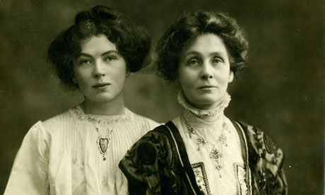
Christabel and Emmeline Pankhurst campaigned for the vote for women of their own class

When Mrs Pankhurst’s suffragettes carried slogans reading "votes for women", which women did they mean? The leading figures in the suffragette movement were middle class. The majority of the foot soldiers were middle class too. Millicent Fawcett's more moderate suffragists, the NUWSS, also included substantial numbers of working class women. And there were a number of other women’s suffrage organisations which were predominantly or exclusively working class, e.g., the Lancashire and Cheshire Textile and Other Workers Representation Committee.
In contrast, the Pankhurst's WSPU were interested only in acquiring the vote for "respectable", i.e., middle class, women. Quoting again from Sean Lang, "Parliamentary Reform, 1785-1928",
"The question of which women should get the vote, and on what basis, had an even more divisive effect on the already chronically divided women's suffrage movement. Millicent Fawcett's National Union of Woman Suffrage Societies … comprised no fewer than sixteen separate suffrage groups, though at least it succeeded in holding them together - Mrs Pankhurst's Women's Social and Political Union went through seven bitter splits in the first ten years of its life. The key role of Mrs Fawcett's Suffragists in mobilising working-class support has been stressed by Jill Liddington and Jill Norris; by contrast the suffragette leadership, Emmeline and Christabel Pankhurst, and Emmeline and Frederick Pethick Lawrence, were at best indifferent to working-class support and by 1912 increasingly opposed to it, to the point of expelling the socialist-sympathising Sylvia Pankhurst altogether… In 1907 the WSPU had changed its stated aim from ‘Votes for Women on the same terms as it may be granted to men' to 'Tax-paying women are entitled to the parliamentary vote', which convinced Labour and the Liberals, not to mention the NUWSS, that the WSPU was, to all intents and purposes, a stooge for the Conservative Party."
[A brief aside: The claim that Emmeline Pankhurst might be a Tory stooge is hardly contradicted by the fact that she later stood as a Tory candidate for Stepney, in 1927. Given this historical background, it is a delicious irony that left-leaning feminists today have adopted the Pankhursts as their heroes - stooges of the Tories! However, perhaps it does make sense. Sean Lang notes that the Pankhursts "became stridently anti-male, ruthlessly dropping even the most loyal of their male supporters from the WSPU, and claiming, as Christabel did in 1913 in The Great Scourge, that men were little more than carriers of venereal disease". Christabel had published the material which later appeared in The Great Scourge in the WSPU magazine The Suffragette. Emmeline notes in her autobiography that “There is no question that a great deal of the animus directed against us during 1913 and 1914 by the Government was due to sex bitterness stirred up by a series of articles written by Christabel”. In a letter to CP Scott on 29 November 1909, Lloyd George confided that talking to Christabel Pankhurst was ‘like going to a lunatic asylum and talking to a man who thinks he is God’. Fitting, then, that she later took to lecturing on The Second Coming. During the height of the suffragette protests, Christabel fled to Paris to avoid re-arrest. In 1921, shortly after women had attained the vote in the UK, she moved to the USA. Christabel returned to the UK briefly in the 1930s, stayed long enough to be honoured as a Dame, and then fled back to the USA at the outbreak of WW2.]
But back to the suffragettes.
Emmeline and Christabel Pankhurst’s lack of concern for the enfranchisement of working class men was their undoing. Mrs Pankhurst regarded the Manhood Suffrage issue as merely a ruse to push female enfranchisement off the agenda. Pankhurst was actually pursuing a rather modest target of “the vote for women on the same grounds that it be granted to men”, or variants on that theme. This would have enfranchised only a relatively small number of women. Simply put, she was not too concerned about giving the vote to the working class, of either sex. She imagined that this would only make the task harder to achieve. On this point she was both right and wrong.
The key factor which she, and those other suffragists who campaigned only for votes for women, did not understand was that the main barrier to female enfranchisement was the fact that men had not yet achieved universal suffrage. There was simply no party political route to passing a Bill to give the vote to women without first having enfranchised working class men. They failed to appreciate that the only way through the political thicket to achieve votes for women was via votes for working class men too. This was the Big Snag and it worked like this.
Consider any attempt to give the vote to some women without extending the franchise to more men. Which women could possibly receive the vote? Well, at most, only those women who ‘matched the enfranchised men’, that is, the upper half of society. Broadly, the multiple attempts to enfranchise some women prior to 1918 had all been constrained by this consideration, and, in practice, tended to offer the vote to an even more restricted class of women – “the most respectable” women, you might say.
But this meant – or was presumed to mean - predominantly women who would vote Conservative. By giving the vote to a few million new Tory voters, the Liberal and Labour Parties would, to put it bluntly, be shafted in the elections. So the very Parties which were sympathetic to votes for women, in principle, got cold feet when it came to the practice. And Asquith – who was Prime Minister throughout most of the suffragette period – was Liberal, as was most of his Cabinet.
The Conservatives were not, in general, ideologically in favour of women’s suffrage – though it is noteworthy that quite a few individual Tories were supportive (including Arthur Balfour, who was conservative Prime Minister between 1902 and 1905). However, there was a threat that the Conservatives might support limited suffrage for a few ‘respectable’ women because of the electoral advantage it was presumed it would give them. The dominance of the Liberal Government after 1905 would ensure this threat to their election chances would not materialise, despite a majority of their MPs supporting female enfranchisement in principle.
Of course, this problem could have been overcome by also granting the vote to working class women. But this could obviously not be done unless working class men also were given the vote. For this reason it was a party political impossibility to give the vote to women - any women at all - until the vote had first been extended to all working class men. In short, the only viable route to female enfranchisement lay through universal adult suffrage. The barrier to female enfranchisement was the class issue of enfranchisement of the working class, not primarily an issue of sex.
The Conservatives would be largely opposed to universal suffrage, for both electoral reasons and ideology. The Labour Party, which was growing in strength, was passionately in favour of universal manhood suffrage – and later would come on board with the women’s claims. The Liberal Party, however, was split – and particularly those who mattered – the Liberal Cabinet. As Mrs Pankhurst herself was to observe, it was far harder to drum up support for working class male suffrage than for tax paying women’s suffrage. Unfortunately, Emmeline Pankhurst would never see clearly that the former was the barrier to the latter.
This was the Big Snag. But almost all players in the saga were very slow to grasp its nature. And to this day it remains little appreciated that what the female suffragists had to overcome was not a misogynistic male hegemony but a male ruling class which was reticent about handing power to the working class.
There is plenty of evidence to support this perspective. Sandra Stanley Holton in her 1986 book Feminism and Democracy, writes, of the situation circa 1906,
“Although in general the Liberal Party rank and file was sympathetic to the cause of women’s enfranchisement, the party’s leadership was seriously divided and contained a number of committed antisuffragists like the future prime minister, Herbert Asquith. Moreoever, even among those within the party and the cabinet who supported the principle of sexual equality, there were many, like Lloyd George, who feared equal votes for women. This body of Liberal opinion believed such a measure would, in the main, enfranchise the wealthier woman and thus damage their party’s interests, for the existing franchise was based on property qualifications.”
So what Emmeline Pankhurst was attempting to do was an impossibility. The only way forward was universal suffrage, that is, democracy. Emmeline should have listened to Sylvia.
And, crucially, this Big Snag to the adoption of female suffrage is why WW1 was key to women acquiring the vote - because it was WW1 which resulted in the vote being given to working class men, the essential precursor to the female vote. It was WW1 which unsnagged the Big Snag.
The true history of ‘votes for women’ is therefore really the history of universal suffrage, which is the history of the working class struggle towards democracy.

12. The History of the Parliamentary Franchise in Numbers

Prior to 1918 virtual all those with a Parliamentary vote were men. You may be surprised by the cautious “virtually all”. We may be confident that Parliamentary voters were heavily dominated by men – and certainly were exclusively men between 1832 and 1914. But prior to 1832 – incredibly - it is not certain whether some women may have voted. I quote from House of Commons Research Paper 13/14, The History of the Parliamentary Franchise, by Neil Johnston (March 2013).
“Ancient voting rights did not specifically prohibit women’s suffrage. Before 1832 the disfranchisement of women had been by custom rather than by statute but there has been little research into the subject and “it is impossible to conclude that women never voted”.”
The Great Reform Act of 1832 was the first time that female persons had explicitly been excluded from the Parliamentary franchise. This is worth emphasising in view of the immense amount of angst over women’s suffrage and the claims that this was due to patriarchy oppression. Prior to 1832, that women generally did not vote was a social convention. And, amazingly, it appears to be unknown whether some women did, in fact, vote. One wonders about the real life equivalents of rich and influential characters in fiction, such as Lady Catherine do Bourgh in Pride and Prejudice. Certainly, it’s hard to imagine the fictional character not insisting on a vote – determined as she was to control everyone’s lives in other ways – though no doubt she’d have sent her lackey, the Reverend William Collins, to actually cast her vote.
The property-based right to vote goes back at least to King Henry VI in 1432 when it was established that only Freeholders with property worth 40 shillings or more could vote. The full statement of the basis of the franchise would be complex, including various exceptions in the Borough vote and the University vote. But the 40 shilling Freehold requirement captures the bulk of the issue.
It is tempting to assume – as I did for a long time – that the proportion of people eligible to vote only ever increased. Not so. In fact, prior to 1432 there was a view among the great and the good that,
“some elections had involved too great and excessive number of people…of whom the greater part are people of little or no means and that these people pretend to have an equivalent voice…as the most worthy knights or esquires dwelling in the same counties.”
[Quote from The History of the Parliamentary Franchise, House of Commons Research Paper 13/14 by Neil Johnston (March 2013)]
This complaint by the ‘better class of persons’ was the cause of Henry VI introducing the 40 shilling Freehold requirement. It would take exactly four centuries to merely start to reverse this basis for a limited franchise.
The proportion of people with the Parliamentary vote prior to 1832 is difficult to establish precisely. In the sixteenth and seventeenth centuries it was probably around 1% of the adult population, or 2% of men over 21. However immediately prior to the 1832 Act this may have risen to around 4% of adult men due to the effects of inflation on the 40 shilling requirement – which remained unchanged for four centuries.
The effect of the 1832 Great Reform Act was to increase the franchise to perhaps around 8% of adult men over 21 years. This increased slightly over the years to the second Reform Act, being perhaps 12% of men by 1866. The second Reform Act of 1867 increased this substantially to about 32% of adult men, and the third Reform Act of 1884 increased it further to about 56% of adult men over 21.
In practice, substantially fewer than 56% of men ever actually registered to vote, simply because of the logistical difficulties involved in registering at that time.
It is worth noting that until 1872 many men regarded the possession of the vote as more of a liability than a blessing. The reason was that voting was not secret until the Ballot Act of 1872 made it so. Powerful local dignitaries could see how men had voted and consequently pressure was exercised upon men to vote in accord with those whose patronage was crucial to their livelihood. If a man was under pressure from opposing camps he could not avoid angering one or the other. Hence possession of a vote was not an unalloyed joy.
Period | Electorate as percentage of male population aged 21 and over
Before 1832 | ~2% to ~4%
1832 - 1867 | ~8% rising to ~12%
1867 - 1884 | ~32%
1885 - 1918 | ~56%
 | Electorate as percentage of total population aged 21 and over
1918 - 1928 | 74% to 78%
1928 onwards | 100%
[These data were taken from The History of the Parliamentary Franchise, House of Commons Research Paper 13/14 by Neil Johnston (March 2013)]

So, by the outbreak of WW1, and throughout almost the whole of that conflict, only 56% of men over 21 years old had the vote. Take into account that none of those young men of eighteen to twenty, of whatever class, would have had the vote. Take into account also that there were 250,000 under-aged boys who lied their way into the British army during that war – and another 100,000 in the navy. Take all that into account and a clear majority of those who died or were maimed in WW1 did not have the vote.
And how many was that? Well, counting British only there were 880,000 deaths and more than double that number seriously wounded who survived. Count everyone and there were 8.5 million dead and 37 million other casualties. This is not a digression. WW1 is the crucial ingredient in the final chapter of this story – this story of emerging democracy and the Parliamentary vote.
Leaping ahead of ourselves, immediately after the passing of the 1918 Representation of the People Act the numbers of men and women on the electoral register were 12,913,166 and 8,479,156 respectively. [F.W.S. Craig in British Electoral Facts 1832-1987 (Parliamentary Research Services, 1989)]. So, in 1918 women were 40% of the electorate.
By 1928 when the follow-up Representation of the People Act was passed, giving women the vote on the same basis as men, i.e., at 21 years, the number of men on the electoral role had deceased to about 12,250,000 due to further war deaths having been taken into account. The number of women with the vote – now essentially all women aged 21 and over, was about 2 million more than men, around 14,250,000. Women were then nearly 54% of the electorate. Women have been the majority of the electorate ever since.
It is worth contemplating this: there was only a ten year period in the entirety of history – between 1918 and 1928 - in which all adult men had the vote and the number of men with the vote exceeded the number of women. For a bunch of patriarchal overlords, they sure didn’t do it right.

13. The Parish and the Poor Law
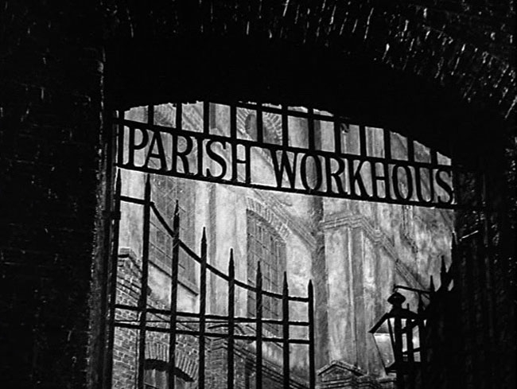
Parish Workhouses were deliberately harsh as a deterrent
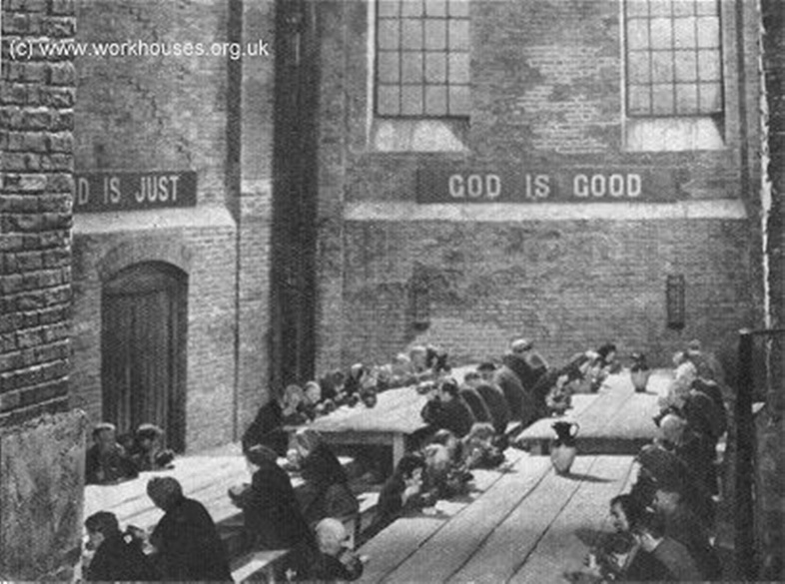
Workhouse Dining Hall
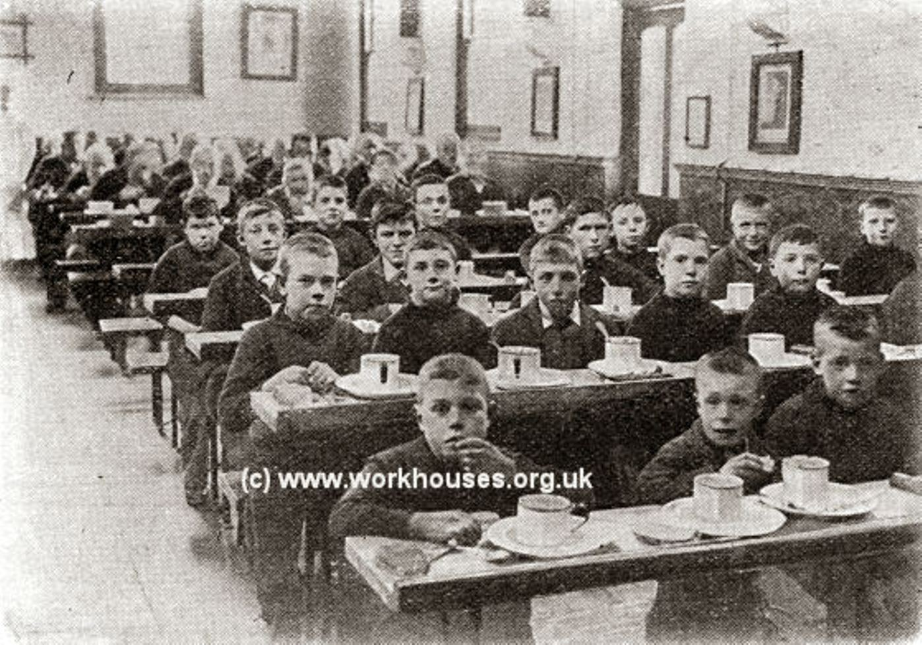
Workhouse Boys. Men, women and children were segregated in the workhouses, making them an even more harsh environment

These days we think of real power lying in the central Westminster government, whilst local government has relatively few powers. But in the Victorian era, and before, there was no welfare state, no state education, no national health service and most people did not pay tax to central government. The business of Parliament was far narrower than it is today. Much of its business was war, conquest and empire. The rest was skewed towards the interests of the wealthy: the landed gentry and the emerging capitalist class.
On the other hand, those issues which touched more directly on ordinary peoples' lives were addressed locally, primarily at the Parish level. The Parish electorate in England and Wales was generally broad and inclusive. There was the potential for elections for a range of parish officers including constables, highway surveyors and overseers of the poor. Of greatest importance was administering the poor law, upon which most of parish funds were expended. This involved parish assistance to widows or abandoned women with children as well as help for the sick and elderly. These are the issues in which women would be most interested, rather than parliamentary issues.
Appropriately, it would seem that women had long had the vote at Parish level. Certainly, some women had been allowed to vote in local elections since 1818, this right for unmarried women being authorised by The Vestries Act. Not only that but women also held office within the parish, at least from early Victorian times and probably earlier. Although there were attempts to reform and codify these practices in the early nineteenth century, in reality, in many Parishes, democracy was in the ascendant far earlier than it was at the Parliamentary level.
Women's close involvement in local government, even very early in the Victorian era, has been widely unappreciated. This has given rise to the false impression that women were disenfranchised from all forms of public influence. In truth, women's enfranchisement differed little from that of men - at this local level - though both were subject to wealth (property ownership or being a ratepayer, etc). However, modern historical scholarship is revealing the truth. The publicity blurb for the book Ladies Elect: Women in English Local Government, 1865-1914 by Patricia Hollis (Oxford University Press, 1989) reads as follows (slightly abridged), "This is a pioneering study exploring the world of women who held office some fifty years before they had the parliamentary vote. It is based on the records of some 20 towns and 10 rural districts in England. Fifty years before the suffragettes fought to have the parliamentary vote, women in England were able to elect, and be elected to, local district councils, school boards and Poor Law boards. This pioneering study explores the world of those women who held office on behalf of other women, children, the old and the sick....Local government offered that conjunction of compulsory philanthropy, municipal housekeeping and local responsibility which made it a sphere suitable for women".
Direct evidence of women voting in the early Victorian era is rare. But this is because records of parish elections seldom survive (unlike parliamentary elections). However, occasionally poll books for parish elections surface in the archives. One example is discussed in
The Political Worlds of Women: Gender and Politics in Nineteenth Century Britain (2013) by Sarah Richardson, Associate Professor in History at the University of Warwick. This relates to St Chad’s parish in Lichfield in May 1843. The poll book can be found in the papers of the solicitors who were the Conservative party agents. It was probably used to canvass local opinion in-between parliamentary elections. 30 women voters are listed in that small Parish, including one plural voter, Grace Brown, who had four votes because of her wealthy status.
The reason that women were able to vote was due to the fact that many local franchises were based upon payment of poor rates, irrespective of the sex of the person paying those rates. This was effectively a household franchise, and single or widowed women who owned or rented eligible properties were able to exercise the vote. In other words, local voting rights were gender neutral (although the bias of property ownership by men resulted in a de facto bias in voting rights). The organisation and powers of local government had arisen from immemorial custom and incorporated elements of the common law as well as combinations of by-laws and private and public parliamentary acts. It seems likely, then, that women had enjoyed local voting rights, and the holding of local office, even before the Victorian era - perhaps since Anglo-Saxon times.
Women’s local enfranchisement continued to strengthen throughout the Victorian period. In 1869 single women ratepayers got the vote in municipal elections. From 1870 women could vote in elections to the new School Boards and also hold office in that capacity. Women could also vote under the 1888 Local Government Act and in 1894 they were allowed to sit on local councils. By 1900 there were something like a thousand female elected Poor Law Guardians.
Emmeline Pankhurst was herself both a School Board member and a Poor Law Guardian. When Dr Pankhurst, her husband, died in 1898, Emmeline Pankhurst resigned her unsalaried position on the Board of Guardians of the Poor Law and was, and I quote,“almost immediately appointed to the salaried office of Registrar of Births and Deaths in Manchester”. Clearly, she was rather well connected.
Let us not forget that life was hard in those times. The stories that Mrs Pankhurst relates, from her experience both as a Poor Law Guardian and as Registrar of Births and Deaths, are undoubtedly true. Underage pregnancies were common and the blame and stigma did often devolve unfairly on the girl literally left holding the baby, though ‘shotgun’ marriages were even more common.
It is worth emphasising the dramatic change which came about in the administering of poor relief just before the Victorian era with the 1835 Poor Law. This Act was meant to simplify the maze of parish-by-parish relief schemes which had grown up, entwining the whole country like clinging ivy, ever since Henry VIII closed the monasteries and with them their alms for the poor. Things had got into a pretty mess by the 1830s. In 1835 Edward Gulson, who did some prying for the Poor Commissioners in the still un-Unionised parishes of Oxfordshire, reported that rate-receivers lived better than rate-payers. One woman even paid the parish to let her lodge in the poorhouse where paupers ate meat daily. A gang of fit men, paid by the parish to mend roads, played pitch and hustle with the parish's money and took paid leave to go bull-baiting.
One may doubt whether those anecdotes were truly representative of the majority of those on poor relief. There will always be those who resent public funding for those who are not self-supporting; and there will always be those who game the system and hence provide ammunition to the former. However, what is certain is that the 1834 Poor Law was intended to reduce its costs. The new system was both unified and rigid. At the top it was run from London by paid Commissioners. Locally it was run by elected Boards of Guardians, often petty tradesmen with a vested interest in being stingy to the poor. Parishes were lumped together into Unions the better to support the new brick workhouses which, like jails, were meant to deter, not attract; to break, not protect. Only the utterly desperate and beaten would live in them. That was their point.
I recall my wife's grandmother, who was born in 1894, still having a visceral fear of the Workhouse, despite never having been under threat of entering one. This was the oppressive system which Mrs Pankhurst helped administer, though its failings were in no way her fault. Indeed, she railed against them. One wonders, though, whether she knew how recent an innovation were the workhouses.
In her book, Emmeline Pankhurst remarked, in the context of her experience as a Poor Law Guardian, “When women have the vote they will see that mothers can stay at home and care for their children. You men have made it impossible for these mothers to do that”. Ironic, I think, in view of the fact that feminism has made it all but impossible for most mothers to do that – and, indeed, exerts an ideological image of failure upon women who choose to be full time stay-at-home mothers.

14. Emmeline Pankhurst’s Errors and the Early Attempts at Female Enfranchisement, 1884 - 1914
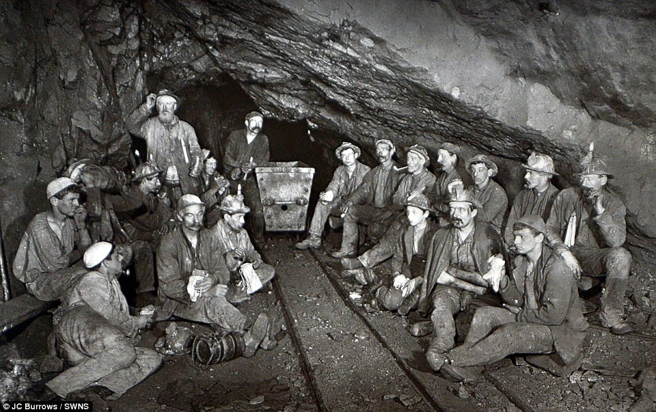
Are none of you men? (Cornish miners)
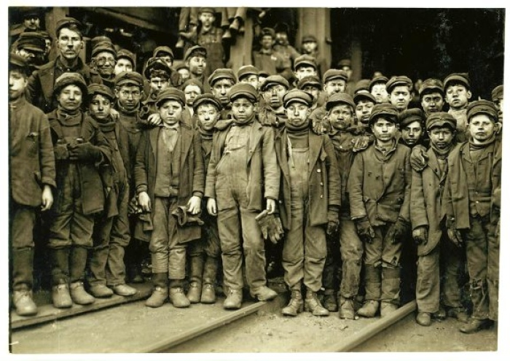
Are none of you men? (American boy miners)

Quotes in this Section are from Emmeline Pankhurst’s book My Own Story.
I will not try to give a complete account of all the attempts which were made to pass Bills giving limited suffrage to women in the period between the Third Reform Act in 1884 and the start of WW1. The message is: there were many. The further message is: many of them demonstrated a clear majority in Parliament in support of some form of female suffrage.
Do also recall that the drive for female suffrage really got underway during the debates leading to the Second Reform Act in 1867 when only around 10% of men had the vote.
I emphasise these points to illustrate how erroneous is the ‘patriarchal oppression’ version of women’s struggle for suffrage. On the historical perspective, women were hardly very much behind men in the struggle.
I have already mentioned Mrs Pankhurst’s observation that, in 1884, “we had an actual majority in favour of suffrage in the House of Commons”. She also remarks, of a Bill introduced by Lord Haldane in 1890, that, “It was a truly startling Bill, royally inclusive in its terms. It not only enfranchised all women, married or unmarried, of the householding classes, but it made them eligible to all offices under the Crown”.
Note that by “royally inclusive” she means “of the householding classes”.
This Bill failed, of course, despite said majority. Mrs Pankhurst was not stupid. She knew from experience the crucial distinction between having a majority in the House of Commons and being able to get a Bill passed. Bills get through if supported by the Government, else not – on the whole. Private member’s Bills rarely succeed. She writes,
“repeated experiences had taught us that the only way to attain women’s suffrage was to commit a Government to it. In other words, pledges of support from candidates were plainly useless. They were not worth having.”
She further drives this point home, referring to the position in 1906, thus,
“For seven years we had a majority in the House of Commons pledged to vote favourably on a suffrage Bill. The year before they had voted favourably on one, yet that Bill did not become law. Why? Because even an overwhelming majority of private members are powerless to enact law in the face of a hostile Government of eleven Cabinet Ministers.”
Emmeline Pankhurst came hard up against the Big Snag, but never quite accepted the problem. Here she is writing of one of the many attempts at Bills well before even the Conciliation Bills, this one in 1907,
“A number of professed suffragists in the House began to complain that Mr Dickinson’s Bill, practically the original Bill, was not ‘democratic’ enough, that it would enfranchise only women of the upper classes – to which, by the way, most of them belonged.”
She makes a very similar observation in the context of the first Conciliation Bill in 1910. She notes, “The original suffrage Bill, drafted by my husband, Dr Pankhurst, giving the vote to women on equal terms with men, was abandoned, and a Bill was drawn up along the lines of the existing municipal franchise law.” And tellingly she adds that, “The Conservatives insisted on a moderate Bill, whilst the Liberals were concerned lest the terms of the Bill should add to the power of the propertied classes.”
It could hardly be clearer. The Tories would only entertain enfranchising suitably respectable women, who might be supposed to be predominantly Tory voters. But the Liberals were against it for the same reason. And so was the Labour Party, who were ideologically committed to universal male suffrage, and later would add women to that demand.
Mrs Pankhurst chose not to see that this was the Big Snag. She did not want to bring Manhood Suffrage into her orbit. This was, to a degree, understandable because she knew that acquiring the vote for working class men would be even harder than getting pledges of support for the enfranchisement of ‘respectable’ women on the same terms that men already enjoyed. Indeed, in regard to the latter, no persuasion was necessary – there was already a majority. She wrote,
“a Labour party could not be satisfied with anything less than universal adult suffrage, but it was clear that no such sweeping reform could be effected (sic) at that time, unless indeed the Government made it one of their measures. Besides, while a large majority of members of the House of Commons were pledged to support a Bill giving women equal franchise rights with men, it was doubtful whether a majority could be relied upon to support a Bill giving adult suffrage, even to men.”
…do note that “large majority” and how it demolishes the idea of a hostile hegemony of misogynistic men withholding the vote from women. No, this was the ruling class remaining very reticent about granting the vote to the working class, of either sex.
Whilst Pankhurst saw her struggle entirely in terms of women battling against men, she refused to acknowledge the crucial class issue which prevented her succeeding. And she was herself undeniably of the bourgeoisie not the proletariat.
Very often it was working class men that her rallies addressed. Yet she seemed insensitive to how they would receive her preaching about votes for women – votes they mostly did not have themselves. This insensitivity would surface even more egregiously during the war. On one occasion – the only one, I think, in which she was physically attacked by members of the public – she did finally notice that some of the male sex may have problems of their own. She writes of the incident,
“the ring of men drew closer. I looked at them, in their drab clothes smeared with yellow pit-clay, and they appeared so underfed, so puny and sodden, that a poignant pity for them swept over me.”
Unfortunately, fearing attack, her gynocentric instincts quickly resumed dominance. With staggering lack of psychological insight she stupidly cried, “Are none of you men?” (emphasis hers). So, the attack began. Make no mistake, they attacked her despite her sex, not because of it. They attacked her because she was a toff, because as a toff she’d come campaigning for rights for herself whilst not recognising theirs. The final straw was her imperious tone.
To anyone who struggles to understand the point, it is this. You can, with impunity, mock a man whose self-respect is secure. To mock a man whose self-respect has been reduced to almost non-existence by societal disadvantage is another matter. By doing so you threaten what little he has left. You can expect an intemperate response.
Of her organisation, the WSPU, Mrs Pankhurst boasted, “We (the WSPU)…differ from other suffrage associations, or from others existing in 1906, in that we clearly perceived the political situation that solidly interposed between us and our enfranchisement”.
She was partly right. She correctly understood the power of the Government to triumph over the majority will of Parliament. But the boast is unfortunate in view of her two great errors of understanding:-
- She failed to appreciate that her brand of activism could never prevail alone but could only be useful in conjunction with quieter politicking. The WSPU was one half of a good cop / bad cop routine. It is always the good cop that gets the confession, and that wasn’t Mrs Pankhurst.
- Her second great error, which she shared with many in other suffragist organisations, was the failure to appreciate the key Party Political link between male and female suffrage - the Big Snag. She knew that it was easier to get support in principle for the enfranchisement of ‘respectable’ women than for working class men. But she failed to see that Party politics required the latter before the former. It is not clear that any suffrage campaigners truly understood this clearly – though certainly many made universal suffrage their aim, not merely ‘votes for women’ – Sylvia Pankhurst for one.
Actually Mrs Pankhurst made a third error – she failed to appreciate that her middle class perspective was increasingly isolating the WSPU from the broader suffragist movement. Sean Lang, in "Parliamentary Reform, 1785-1928", writes,
"But by far the most controversial and divisive aspect of the whole controversy over female suffrage was the suffragettes' use of violence... No other issue split the women's movement so decisively. The middle-class activists of the much larger NUWSS were dismayed to see the effects of their hard work jeopardised by the suffragette tactics; even stronger was the disgust of working-class suffragists. One suffragette activist emerged from seven days in Holloway to find she had to run a gauntlet of her suffragist workmates, who spat at her as she walked between them. It was all very well for middle-class suffragettes to get themselves arrested, knowing they had servants at home to see to their children and keep the household running; working-class women, for whom the suffragettes had little enough time anyway, could hardly afford to engage in that sort of behaviour - nothing alienated women from the suffragettes more than this insistence on violence."
That the bulk of the women’s suffragist movement did not approve of WSPU violence is testified by the banner under which Millicent Fawcett addressed public meetings, which read “Law Abiding Suffragists”. In seeking the vote for women ‘on equal terms with men’ or for ‘tax paying women’, the WSPU had little to offer the working class – of either sex.
Katharine Bruce Glasier observed of the name Women’s Social and Political Union that it would be better re-arranged as the Society Woman’s Political Union. She wrote in The Labour Leader in 1908, “Disillusion with the WSPU among working-class suffragists was increasingly evident by this time. Nellie Best of Middlesborough wrote to The Woman Worker that she had heard some WSPU meetings took place in evening dress. She asked, ‘is it intended to debar servants, laundresses, etc.?”
But it was not only the WSPU leaders and membership which were middle or upper class; it was also their financial backers. He who pays the piper calls the tune. The WSPU backers would have influenced the WSPU tactics. Holton observers that, “any association between suffrage and working-class protest threatened to antagonise many amongst the WSPU’s wealthier supporters”.
Simon Webb informs us that in 1908/9 the WSPU’s income was more than double that of the Labour Party. Little of this huge WSPU income derived from their one-shilling membership fee. Mostly it came in the form of large donations from wealthy upper-crust women, including Lady Wolsey; Viscountess Harberton; Lady Sybil Smith; the Honourable Mrs Hamilton Russell; Muriel, Countess de la Warr; Princess Sophia Dhuleep; the Honourable Mrs Haverfield; Lady Berkeley and Lady Brassey. Some such women were donating what would, in today’s money, be six figure sums.
[Incidentally, this explains one of the tactics used by the WSPU. When campaigning against a parliamentary candidate – which was their basic approach – they would arrive in a town before the man in question. They would then hire every existing venue, every hall and potential speaking place, as a means of de-platforming the opposition. This is a tactic which required plenty of money].
The 1910 Conciliation Bill (titled, “A Bill to give the Vote to Women Occupiers”) passed its second reading with a majority of 109…but it was buried by Asquith who condemned it to “a Committee of the Whole House”, a standard tactic used to frustrate a Bill. The Black Friday riots, in which many women were arrested, followed its abandonment. Those arrested bear further testament to the class of supporters the WSPU enjoyed. They included,
- Miss B. L. Barwell, daughter of Major-General Barwell and Countess Elsie Leiningen,
- Miss Helen Craggs, daughter of Sir John Craggs,
- Mrs. Marshall, of Theydon Bois, daughter of Canon Jacques and niece of Captain Baldwin, the African explorer;
- Mrs. Massey, daughter of Lady Knyvett,
- Mrs. Morrison, of Australia, daughter of the late Sir T. Murray, Speaker of the New South Wales Assembly,
- Miss Wolff Von Sandau, granddaughter of Dr. E. Schwabe, private chaplain to the late Duchess of Kent,
- Mrs. Mary Taylor, granddaughter of Mrs. John Stuart Mill.
- And Mr. H. A. Franklin, one of the men taken into custody, nephew of Mr. Herbert Samuel, the Postmaster-General.

To their disappointment, the prisoners were released without charge under the orders of the Home Secretary, Winston Churchill. This is noteworthy because suffragette campaigning against him had earlier caused Churchill to lose his seat in Manchester.
The second Conciliation Bill, in 1911, was titled, “A Bill to Confer the Parliamentary Franchise on Women”. Despite the title, it would only have given the vote to upper crust women. This Bill also passed its second reading, by a majority of 137. This second Conciliation Bill, like the first, received the vigorous support of the WSPU. It was estimated that it would enfranchise some 1.5 million women. But the Prime Minister, Asquith, introduced an amendment which Pankhurst rightly considered to be a wrecking amendment. He suggested that all wives of voters be given the vote.
Pankhurst wrote,
“The inevitable effect of such an amendment would be to wreck the Bill, since it would have enfranchised about 6 million women in addition to the million and a half who would benefit by the original terms of the Bill. Such a wholesale addition to the electorate was never known in England; the number enfranchised by the Reform Bill of 1832 being hardly more than a million. The Reform Bill of 1867 admitted a million new voters, and that of 1884 perhaps two millions.”
Mrs Pankhurst alludes here to the shear improbability of introducing 6 million new women voters in a single step – and hence the wrecking nature of the amendment. The irony, though, is that just seven years later the 1918 Act would introduce some 8.5 million women to the franchise, plus a further 5.5 million men, a total of 14 million new voters. This displays clearly the power of the war in making possible what had previously been beyond credibility.
Sneaky Mr Asquith certainly was. His Conciliation Bill amendment was almost certainly a deliberate wrecker – naughty man. And we know why, don’t we? That’ll be the Big Snag. He couldn’t afford to have only a tranche of supposed Tory voters to be newly enfranchised.
Asquith was shortly to announce the Government’s intentions to bring forward, in the next session, a Manhood Suffrage Bill, aimed at extending the male franchise and sweeping away the existing property-based franchise. He promised it would be phrased in terms easily capable of amendment to include women’s suffrage. I trust it is now clear why he would do this? To defeat the threat from the Big Snag, he must needs give priority to extending the working man’s franchise. So long as that was assured, he could afford also to tolerate female suffrage in whatever form it might emerge.
One can hardly blame Mrs Pankhurst for being sceptical. Asquith had been largely responsible thus far in scuppering attempts at female suffrage. What Mrs Pankhurst failed to appreciate, however, was the true reason for this reticence – namely the Big Snag – the Party Political impact of introducing large numbers of new voters confined to the ‘respectable’ class whose voting proclivities might be unfriendly to the Liberal Party.
And here Mrs Pankhurst reveals her most serious error absolutely clearly. She wrote,
“Universal suffrage in a country where women are in a majority of one million is not likely to happen in the lifetime of any reader of this volume”
She wrote this in 1914. In just four years time, there was universal suffrage for men and suffrage for the majority of women. And this was despite the excess of women by then being closer to two million than one, thanks to the war. And only ten years after that, full universal suffrage of both sexes – well within the lifetimes of the majority of her readers. And why? Because the true obstacle to women’s suffrage, which Pankhurst’s gynocentrism blinded her to, was the lack of full enfranchisement of men – and this, the Big Snag, was unsnagged by the slaughter of men in WW1. It was this slaughter which finally pushed the democratic sentiment over the finishing line.
In truth the political ground for full Manhood Suffrage was already prepared before the war. But the destruction of any credible electoral role due to the war, coupled with the immense emotional impact of the mass deaths in the trenches, accelerated Manhood Suffrage into enactment, even with the war still raging. That universal male suffrage was the barrier to women’s suffrage is testified by women receiving the vote in the same Act.
Asquith was, perhaps, not quite as duplicitous as Pankhurst thought. I suspect he was serious about the Manhood Suffrage Bill. In the event, the war and the 1918 Act did the job for him. But in 1911 Mrs Pankhurst was becoming distant from political reality. She was contemptuous of the suffragist movement outside her own, increasingly isolated, WSPU. She wrote,
“With sublime faith, or rather with a deplorable lack of political insight, the Women’s Liberal Federation and the National Union of Women’s Suffrage Societies professed full confidence in the proposed amendment to a manhood suffrage Bill, but we knew how futile was that hope”
Mrs Pankhurst would not believe that a Manhood-Suffrage-first approach was not an attempt to bury the women’s suffrage issue, but simply a necessary political precursor.
She failed to understand that the Good Cop would be in charge from this point, and that the role of the Bad Cop (if any) was nearly over. She had never valued the quiet politicking being done by the non-militant lobby.
After the Second Conciliation Bill, Emmeline and Christabel Pankhurst supported no further Bills. They no longer had any hope in the process. In fact they campaigned violently against both the Third Conciliation Bill and the Government’s Reform Bill. As a consequence, the Government moved against the leadership of the WSPU. Mrs Pankhurst and the Pethick-Lawrences received long prison sentenced (though they served little of them due to their hunger strikes). Christabel Pankhurst fled to Paris, where she lived in style in one of the better districts at the expense of the WSPU.
The third Conciliation Bill failed at its second reading, because it was now perceived as rendered redundant by Asquith’s promised Manhood Suffrage Bill – and also risked splitting the Cabinet (a perception that Asquith no doubt encouraged).
Asquith’s Bill was duly withdrawn – floundering against the Tories for the predictable reason – the threat to their election chances with working men enfranchised – the Big Snag struck again.
After the second Conciliation Bill failed in 1911, the suffragettes activities became far more criminal, in fact outright terrorism. What else can one call bombings and arson? What else can you call bombing a house being built for the Chancellor, Lloyd George? There were said to be 250 arson attacks in a six month period in 1913.
Emmeline and Frederick Pethick-Lawrence, who had been Mrs Pankhurst’s loyalist supporters – including hunger strikes and forced feeding - became uncomfortable with the increasing levels of violence and arson being committed by WSPU members. They were obliged to leave the WSPU. This most militant phase of suffragette activity occurred beyond the point at which it could have any beneficial effect. The baton for political progress had already been passed to the non-militant suffragists. But Emmeline and Christabel Pankhurst, increasingly isolated from the broader movement, were unaware of this political reality.
Responding to the question ‘what good did the militancy do?’ Mrs Pankhurst replied, “What good did it do? We have often been asked that question”, she admitted, “even by the women our actions spurred into an activity they had never before thought themselves capable of.” Her answer, essentially, was ‘publicity’. She continued, “our campaign made women’s suffrage a matter of news – it had never been that before. Now the newspapers were full of us”. But it is far from clear that raised public awareness was instrumental in gaining the vote for women. Certainly, the issue had to be put on the agenda – and the suffragettes did that right enough. But it is by no means obvious that the rest of the suffragist movement would not have been sufficient. The suffragettes were, after all, but a small fraction of the suffragist movement.
After the defeat of the final Conciliation Bill and the withdrawal of the Government’s Reform Bill, Holton notes that, “a disintegration was increasingly evident within the WSPU whose leadership continued to pursue its narrow sectarian approach to the issue, and in so doing completed its isolation and marginalisation”.
In 1914 Emmeline and Christabel Pankhurst put themselves out of the picture, ostensibly because of the war. In truth, their WSPU had already become largely irrelevant except as a liability. The suffrage end game which was played out during the war and was left to the rest of the movement. To that we shall turn shortly. But I have not quite done with the Pankhurst’s yet.

15. The Hypocrisy of Emmeline and Christabel Pankhurst
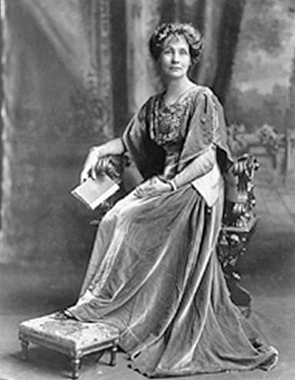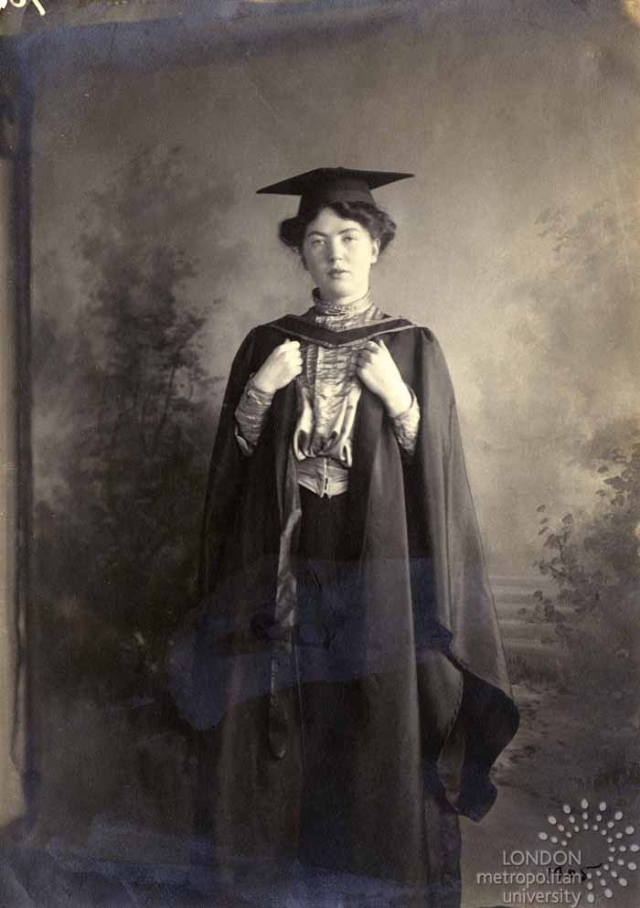
Emmeline and Christabel Pankhurst – The Oppressed
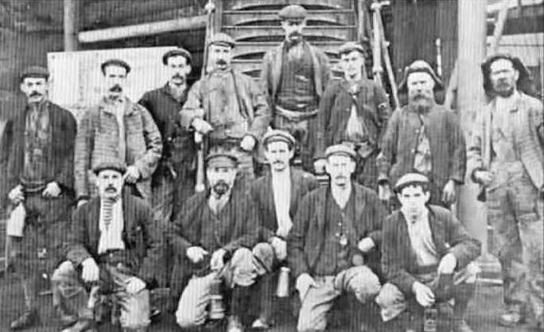
The Privileged (Working Men, England, 1912)
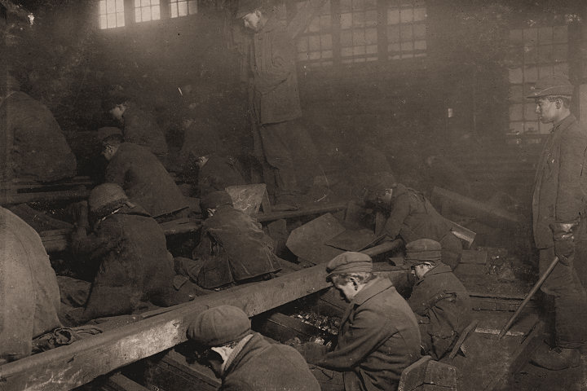
The Privileged (American collection)
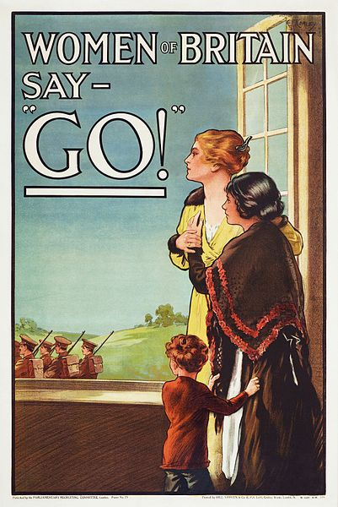
World War One Recruiting Poster
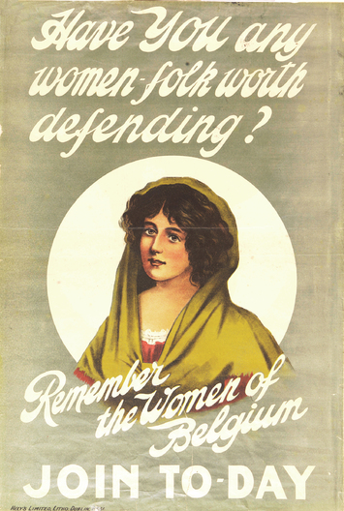
World War One Recruiting Poster
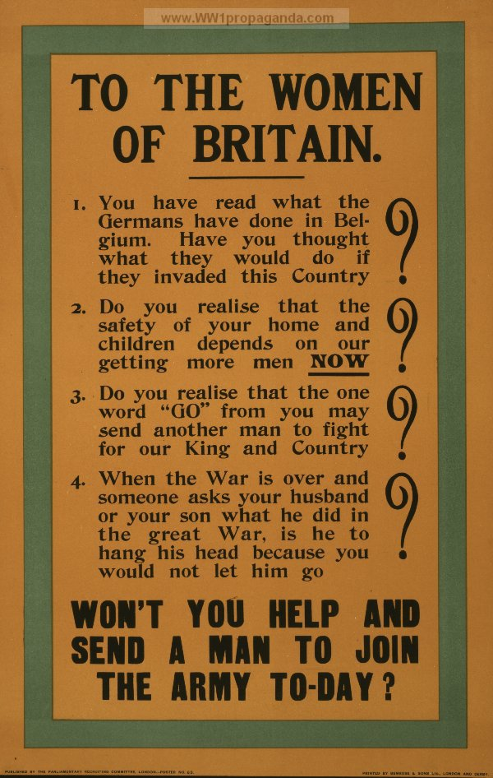
World War One Recruiting Poster

Early in her autobiography, My Own Story, Emmeline Pankhurst writes,
“The militancy of men, through all the centuries, has drenched the world with blood, and for these deeds of horror and destruction men have been rewarded with monuments, with great songs and epics. The militancy of women has harmed no human life save the lives of those who fought the battle of righteousness.”
Within months of writing this at the outbreak of WW1, Mrs Pankhurst would be touring the country addressing crowds of men, exhorting them to join the army and go to fight in the trenches.
How like modern day feminists who constantly remind us that war is all men’s fault. Yet in the UK vote to go to war against Iraq in 2003, 83 women MPs voted in favour, out of the 104 women who voted – a larger proportion of women MPs in favour of war than male MPs (72%). Similarly, the 2015 vote on bombing Syria was carried partly thanks to more women MPs voting in favour (98) than against (83) – and whilst Tory women were whipped to vote in favour, there were substantially more women MPs in the other parties who might have been expected to bring the female vote down against the bombing, especially having a Party political motive to do so. But history shows that women in positions of power have no more reluctance to send men into battle than do male leaders.
It must be very convenient to have someone else do your dirty work – and doubly so if you can afterwards burden them with the moral culpability. But I digress.
During the Great War the suffragettes suspended their campaigning activities. Mrs Pankhurst expressed it thus,
“So ends, for the present, the war of women against men.”
Rather a revealing way of expressing it. And a total, colossal mistake.
After suspending their suffrage campaigning, Emmeline and Christabel Pankhurst took to speaking at recruiting drives for the war. The potential recruits would be largely from the working classes and hence would not have the vote. It surely is just to accuse the Pankhursts of hypocrisy. They were insistent on their own right to the vote whilst remaining safely at home, but at the same time they were happy to send to their deaths men whose right to vote they did not recognise as significant. This must surely rank as one of the most flagrant pieces of political hypocrisy of all time.
But there was worse: the white feather campaign. The suffragettes would patrol the streets looking for any male in civilian dress who might be of fighting age - and shame them by pinning a white feather to their chest. The suffragettes would turn up in force at public meetings, such as at Hyde Park Corner, carrying banners reading "Intern Them All". They were very keen to remind men of what, in their opinion, was a man's duty. They were not so keen on recognising that these same men might also deserve the constitutional rights they claimed only for themselves.
It is perhaps difficult in our modern times to appreciate just how vehemently determined the women of Britain were to send men - all men - to fight in WW1. These are the words which Emmeline Pankhurst used to address recruiting rallies,
"The least that men can do is that every man of fighting age should prepare himself to redeem his word to women, and to make ready to do his best, to save the mothers, the wives and daughters of Great Britain from outrage too horrible even to think of".
What she was thinking of, by the way, were the stories then circulating about the behaviour of the German troops as they tore through Belgium on their way to France. Whilst history has dubbed it the Rape of Belgium, that phrase refers mostly to the shooting of around 6,000 civilians rather than the outrage Pankhurst feared. The shootings were generally for acts of resistance, real or perceived, and so the victims would have been overwhelmingly men.
Pankhurst’s exhortations to ‘save women’ were all that was required to drive men to the trenches. In that age men would gladly self-immolate rather than be called a coward. And as for a man’s duty to "redeem his word to women" this speaks volumes for the pervading sense of obligation to which men were subject - obligation, not privilege.
That the man or boy in receipt of their white feather might be genuinely ill or genuinely under-age did not concern the suffragettes. In fact, many were under-age because they were the ones that had not yet joined up. So 350,000 under-age boys ended up in the army or navy. Others who were white-feathered were simply home on leave. But it was not just white feathers. It was the prevailing gendered society which coerced so many under-age boys to die in the trenches: their role was to be disposable. And if even feminists cannot maintain the fiction of male privilege in the face of this obvious carnage, you can be sure they will blame toxic masculinity instead.

16. The Great Unrest and Men’s Demands
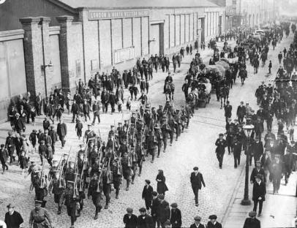
Soldiers parade to intimidate Liverpool dockers, 1911
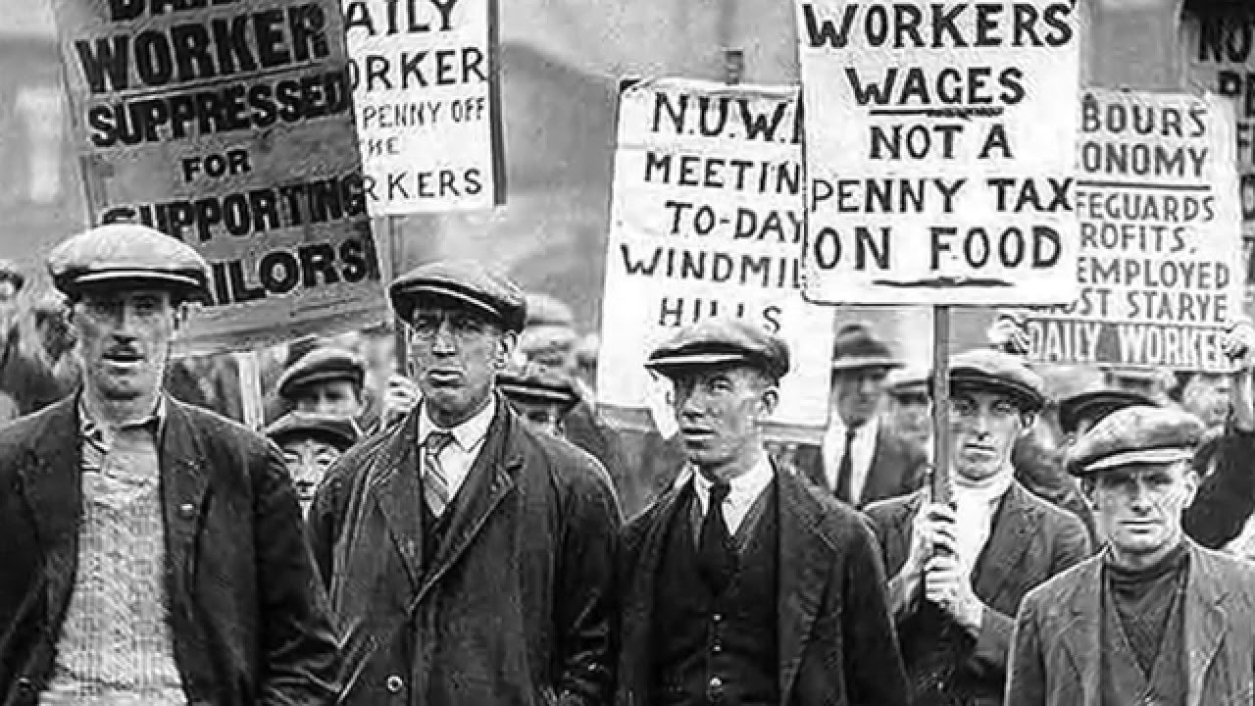
Striking workers, The Great Unrest
To discuss women’s demand for the vote in isolation from men’s parallel demand is to understand neither. Men’s demand for an extended franchise, which meant working class men, is now less prominent in the public mind. The reason is that male working class political action was not focussed on that single issue. Male working class politics had become centred on the Labour Party and the Trade Unions, and also on the more hard line socialist parties, the Independent Labour Party and the Social Democratic Federation. The links between some of the members of these organisations and groups such as the Manhood Suffrage League is noteworthy, demonstrating that extending the male franchise was very much on the agenda – despite its disappearance now from the public memory. But, unlike the female suffragists, the proponents of full manhood suffrage did not see this as an end in itself, nor as their sole, or even their main, policy issue. The main concerns of the Labour Party and the Trade Unions, and the other left Parties, were workers’ rights, pay and conditions. Consequently, the direction of travel was different for men and women, but that does not mean that men were unconcerned about the franchise. Far from it.
As we shall see later, demands for enfranchisement ultimately saw the women’s demands and men’s demands converge.
Just as the issues of male and female enfranchisement cannot ultimately be considered separately, so the issue of extending the vote should not be divorced from the broader political picture. Two other matters, at least, were far more pressing for the political class at the time. One was the Home Rule question for Ireland, a matter that constantly threatened civil war. In comparison, a few misbehaving suffragettes were an irritation rather than a problem. The other issue was the Great Unrest.
The period from about 1910 to 1914 saw an unprecedented number of strikes. There was more strike action in that period than at any time before or since. In 1911 and 1912 about 10% of the workforce was involved in striking. This was the Great Unrest. The characteristic feature of these strikes was that most were unofficial or ‘wild cat’ strikes. In other words, they were not approved by the Unions involved, but arose spontaneously. The reasons for the increased labour unrest is often debated. In part it was probably a response to economic conditions. In part it was due to frustration with the slow progress being made by the Parliamentary approach via the Labour Party. In part it was due to the rather conservative leadership within the Trade Unions which failed to inspire the membership. In part it may have been inspired by ideology emanating from an emerging working class intelligentsia.
One could argue that the establishment contributed to creating the problem with such moves as the Taff Vale Judgement, which ruled that a trade union could be sued and compelled to pay for damages inflicted by its officials. By discouraging official strike action, did this inflame unofficial action? Similarly, the constitutional approach via Parliament was not facilitated by the Osborne Judgement under which trade unions were forbidden to levy the membership for political purposes. The Osbourne judgement was made in 1909 and reversed by the Trade Union Act in 1913, so the ruling was essentially coterminous with the Great Unrest. However, this rather neat-sounding explanation can be countered by noting that Trade Union activity was considerably liberalised by the 1906 Trade Disputes Act.
The role of syndicalism in the Great Unrest has been much debated also. Syndicalism, in its usual form of anarcho-syndicalism, is a socialist doctrine, originating in continental Europe, in which political parties are done away with and each industry is put in the hands of a single controlling ‘syndicate’ of workers. It differs from Marxism in avoiding putting political power in a ‘workers’ party’, believing that State power always corrupts. It is therefore a form of anarchism. Political power is won by the workers staging a general strike and deploying violence and sabotage as necessary.
The site UnionHistory expresses the role of syndicalism in the Great Unrest thus,
“Trade Union membership grew rapidly between 1910 and 1914. This growth - a product of the extraordinary militancy of the pre-war years - exploded in a huge wave of strike action, dubbed 'the great unrest'. The printers' strike of 1911 was the occasion for the establishment of a new workers' daily newspaper in April 1912 - the Daily Herald edited by George Lansbury. The organisers of these pre-war strikes were hostile to the leadership of the industrial and political wings of the labour movement, which they condemned as class collaborationist. Instead they were inspired by syndicalism. Syndicalists were a minority current in the labour movement, but nonetheless they offered a simple alternative to the continued employers' offensive - that of direct action in order to regain some form of workers' control over workplace pay and conditions by utilising the strategy of the mass strike.”
Whilst such a revolution did not ever become widespread in Britain, there is no doubt that syndicalist ideas abounded. The Manchester Syndicalist Education League, the Industrial Syndicalist Education League and the Central Labour College in London all provided means of disseminating syndicalist ideas among intellectuals, trade unionists and workers. The Industrial Syndicalist Education League, founded by Tom Mann, produced its own paper, The Industrial Syndicalist, and staged syndicalist conferences with international attendance.
This Communist site claims that, within months of Tom Mann founding The Industrial Syndicalist Education League, “the country would be gripped by a prolonged strike wave which was heavily influenced by the ISEL’s ideas”. This site claims that,
“For many younger workers the appeal of syndicalism was in its rejection of political parties, combined with the argument that what the working class needed was new forms of union organisation which did away with sectional organisation and replaced it with one union in one industry. The strength of syndicalism lies in the recognition that worker strength lies at the point of production i.e. the workplace, while its weakness is in its rejection of political struggle. For syndicalists the point is that capitalism will be replaced after workers have staged a general strike and have taken control of the workplace…..Many who tried to overcome the shortcomings of existing unions embraced syndicalism. They pushed for the amalgamation of unions within the same industry, and a militant policy of no compromise with the bosses.”
In Durham, the miners took syndicalist ideas into the coalfields to challenge the conservative union leadership. In the railway industry there was a paper, the Syndicalist Railwayman.
This UWE site, referring to Bristol, claims that, “there is evidence that some workers were sympathetic to the syndicalist movement. According to Holton the syndicalist paper Solidarity seems to have had a favourable reception in Bristol. It was available at a newsagent in the Horsefair, Bristol, as well as being sold directly by syndicalist agitators. Bristol could also provide a speaker, a clerk by the name of Herbert Eady, to advocate the syndicalist cause (The Industrial Syndicalist, 1, 9, March 1911, pp. 11-12).
The strikes were often marked by violent confrontation. The most famous was the Tonypandy Riot in November 1910, during which South Wales miners attacked shops and mining officials houses in the town of Tonypandy. In Yorkshire and Nottinghamshire, railwaymen were assisted in acts of sabotage by miners. In Chesterfield strikers set the railway station on fire and were dispersed with bayonet charges. In Llanelli striking railway workers were fired upon by troops and two men were killed. Troops also shot and killed two men during strikes in Liverpool.
In 1911 there was the Seamen’s strike, the London dockers’ strike and the Railway strike. The latter involved not far short of 200,000 men. There was a South Wales coal strike in 1910 and again in 1911 and then a national miners’ strike in 1912 which involved 850,000 men.
In response to the 1910 South Wales miner’s strike, Winston Churchill, as Home Secretary, dispatched infantry and cavalry. However he thought better of sending them against the miners and had them stop at Swindon and Cardiff to stand by. The Metropolitan Police were deployed instead. As often happens when police confront strikers, the former came in for criticism for ‘going too far’. Churchill faced this criticism in Parliament, notably from Keir Hardie. But he was also criticised in The Times for not being tough enough. There is no approbation to be had in such circumstances.
The 1911 Liverpool seamen’s strike again provoked a military response with two gun boats being sent up the Mersey. And again, troops were deployed in connection with the 1911 rail strike to assist strike-breakers keeping the trains running. The authorities certainly viewed the level and intensity of labour unrest extremely seriously. On at least one occasion the military in Bristol fired over the heads of workers, said to be 1,000 strong, attacking a signal box which was being operated by strike-breakers.
Walter Kendall, in his 1969 book The Revolutionary Movement in Britain 1900–1921 (Littlehampton Books) notes,
“The trade union leaders, almost to a man, deplored it, the government viewed it with alarm, the Independent Labour Party regretted this untoward disregard for the universal panacea of the ballot box, the Social Democratic Federation asked, “Can anything be more foolish, more harmful, more…unsocial than a strike”; yet disregarding everything, encouraged only by a small minority of syndicalist leaders, the great strike wave rolled on, threatening to sweep everything away before it.”
Leon Trotsky opined, “In August 1911…a general strike developed on the railways. During those days a dim spectre of revolution hung over Britain”.
Whilst these actions of working men were anti-parliamentary in nature, that can be viewed as frustration with being still unable to influence the parliamentary process effectively due to being disenfranchised. The Labour Party was, obviously, to become a far greater political force once working people had won the vote. To view the female suffrage era in isolation from these male led events, of even greater ferocity, is to distort the history beyond the possibility of any true understanding. The male working class struggle was, in truth, at its height. One might guess that the British establishment was rather relieved to be able to dispatch these Bolshie workers to the trenches of WW1. Who knows what might have transpired else? And the memory of this Great Unrest must surely have played a part four years later when the franchise was back on the agenda with a vengeance.

17. The Constitutionalists and the Convergence on Democracy
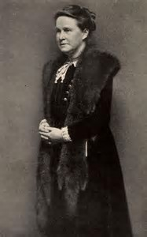
Millicent Fawcett, founder and president of the NUWSS
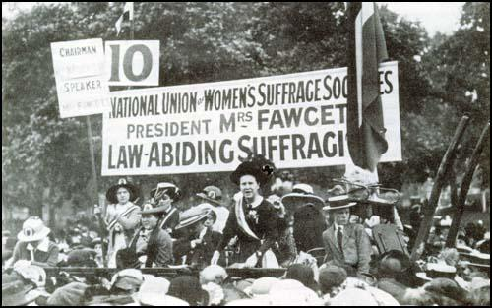
Millicent Fawcett addressing a rally. Note the banner, distancing herself from the Pankhursts

My concentration so far on Emmeline and Christabel Pankhurst and their suffragettes is in danger of reinforcing part of the myth I wish to dispel. Even if you are interested only in the women’s angle on suffrage, it is still grossly misleading to concentrate on the suffragettes. The WSPU was only ever a small part of the women’s suffrage movement. The bulk of the rest of the movement had a lower profile, being law abiding and non-violent, but had better lobbying access to politicians as a result. Following the failure of the second Conciliation Bill, the WSPU would not cooperate with any joint bid including extension of the male franchise, considering such things as merely a ruse to bury the women’s claim. They intensified their terrorist tactics and made themselves irrelevant other than as a liability to the cause.
The most significant of the other women’s suffrage organisations was the National Union of Women’s Suffrage Societies, the NUWSS, founded by Millicent Fawcett in 1897. In the years immediately before , and during, WW1 the complexion of the political approach, led by the NUWSS and others, was to undergo a crucial change.
The NUWSS was formed from the merger or affiliation of pre-existing female suffrage societies. Indeed, by the 1890s there were seventeen individual groups that were advocating women's suffrage in the UK, and more would be formed over the next twenty years. To drive this home, here are the names of some of them which were active at one time or another, sometimes later merging,
- the Women’s Liberal Federation;
- the Liberal Women’s Suffrage Union;
- the Manchester Committee for the Enfranchisement of Women;
- the London Society for Women's Suffrage;
- the British Women's Temperance Association;
- the Woman's Christian Temperance Union;
- the International Woman Suffrage Alliance;
- the Co-operative Women's Guild;
- the Women's Labour League;
- the People’s Suffrage Federation;
- the Women's Freedom League;
- the Lancashire and Cheshire Women Textile and Other Workers Representation Committee;
- the Conservative and Unionist Women’s Franchise Association;
- the East London Federation;
- the United Suffragists;
- and not forgetting, the Men's League For Women's Suffrage.
The interplay between these groups has been clarified by Holton, but the details need not concern us here. Every group included some degree of diversity of opinion. The dividing lines of opinion were twofold.
Firstly there was the issue of militancy versus non-militant politicking. For convenience of exposition I will refer to the latter, following Holton, as the Constitutionalists. It is principally the Constitutionalists upon which the story now turns, though dissident militants will put in another brief appearance. Chief amongst the groups was Millicent Fawcett’s NUWSS, which was broadly Constitutionalist, though there were disparate individual opinions.
The other issue, which divided both the Constitutionalists and the militants, was the relative merit of pursuing women’s suffrage only versus the democratic strategy. The latter would be based on an alliance with the male claim for extended suffrage, emphasising universal suffrage for both sexes. The story of the years immediately before WW1 was a gradual move from the women-only claim to the democratic universalist strategy. This was hesitant at first, with much suspicion between the two sides.
From at least 1904, the Labour Party and Trade Union position was to advocate for adult suffrage. But, quoting Holton, “those suffragists who advocated a feminist-labour alliance were continually to be hampered by the mutual suspicions existing between the two movements”.
“…elements in the Labour Party gave priority to the removal of the property qualifications in the existing franchise law. They opposed equal votes for women as a purely middle-class demand…..The reformulation of the Labour Party demand for an extension of the suffrage in terms of adult enfranchisement might appear to have incorporated the call for votes for women, and to have provided a good basis for feminist-labour alliance. In fact it was to become the root of much suffragist resentment against, and suspicion of, the labour movement. The formulation ‘adult suffrage’ remained ambiguous in the context of a property-based franchise. It could connote either universal suffrage with both the property and sex disqualifications removed, or merely the extension of the existing sexually exclusive franchise to all males.”
The Constitutionalists also had to try to moderate the hostility of many female suffragists to any attempt to broaden their own demand, beyond an equal-franchise law for men and women to a challenge also to the existing property qualifications.
The suspicion of some women suffragists regarding some labour men’s true motives was matched by some labour men’s suspicions regarding some women suffragist’s true motives. From Holton I take this record by Bruce Glasier, Chairman of the ILP, of a meeting with Emmeline and Christabel Pankhurst,
“A weary ordeal of chatter about women’s suffrage from 10pm to 1:30 am…Mrs and Christabel Pankhurst belabouring me as chairman of the party for its neglect of the question. At last get roused – speak with something like scorn of their miserable individualist sexism, and virtually tell them that the ILP will not stir a finger more than it has done for all the women suffragists in creation. Really the pair are not seeking democratic freedom, but self-importance….They want to be ladies, not workers, and lack the humility of real heroism.”
Similarly, much of the trade union movement, especially the miners, were initially opposed to a policy supporting female suffrage precisely because they saw the women’s proposals as merely focussed on the propertied classes – an understandable opinion in view of the WSPU position.
But not everyone was participating in this polarisation. Many women of working class sympathies were finding it offensive to be, and I quote, “mixed up with, and held accountable for, educated and upper class women who kick, shriek and bite”. As the trade unionist Miss Hope said at the 1904 Labour Party conference, “they (the suffragettes) had created a sex antagonism instead of a class antagonism, and it was contrary to the spirit of socialism that that should be so”.
Holton puts it very succinctly,
“At the heart of the disagreement between adultists and (female) suffragists was the question of whether economic-class or sex-class subjection was more fundamental in the construction of social inequality.”
Like the WSPU, many of the non-militant suffragists also reacted with disbelief to Asquith’s promise of an amendable manhood-franchise Bill. They doubted that the adultist position would deliver universal suffrage, that is to say, sex equality. Unlike the WSPU, they reacted more constructively by attempting to bolster the adultist-universalist link, forming the People’s Suffragist Federation (the PSF) to press this case, drawing membership from the parliamentary Labour Party and adultist Liberal members. Women’s suffragists were predominantly sceptical; the WSPU openly hostile.
That Mrs Fawcett was no wiser than Mrs Pankhurst in appreciation the nature of The Big Snag is proved by this reaction to the PSF,
“I do not believe there is much genuine demand for universal suffrage. I certainly have not met with it when I have been about the country speaking….In any case our position is clear. We have nothing to do, and can have nothing to do, with a general alteration of the franchise as it affects men….Any change in the direction of adult manhood suffrage would make our task infinitely more difficult of attainment”
But Fawcett was out of step with some in her own movement. Some resigned from the NUWSS over the adultist issue – including its Secretary and Bertrand Russell. At this point, those in the women’s movement who might be called ‘democratic suffragists’ began to emerge as a separate body of opinion. Margaret Llewelyn Davies in a letter to The Common Cause wrote,
“Those who have initiated this joint movement of men and women believe that the effective political strength and the fighting force of the women’s suffrage movement will be greatly strengthened by showing that it is in harmony with democractic sentiment…..the democratic demand that the suffrage should be placed on a human and not a property basis is the way to secure the passing of a great Reform Bill”.
And she later added, “The PSF is not just playing men’s games with blindfolded eyes. If its women members want manhood as well as womanhood suffrage, they strengthen their demand for the vote for themselves, because the argument for Adult Suffrage is comprehensive and inspiring.”
It should be recalled that the renewed vigour behind manhood suffrage – or adult suffrage – was happening in the context of the Great Unrest. As far as Manhood suffrage was concerned, this was not merely the politics of theoretical democracy but the realpolitik of strikes, civil unrest and the growing threat of state military reaction. The men’s struggle was rather less genteel than the women’s. And if the striking men were less vociferous about the vote as their major objective, recall that this was because the syndicalist position was that political power would be obtained once the means of production was in working class hands. However, the revolutionary disposition of the striking men did not dampen Labour Party determination to secure universal suffrage, at least, initially, for men.
As the suffragettes reached the zenith of their terrorist campaign, they simultaneously became irrelevant – except as a liability. By 1912 the alliance between the bulk of the female suffrage movement and the male-led labour movement, for so long resisted by both parties, became the main game in town. On 30th April 1912 a meeting was held between NUWSS officers and a subcommittee of the Labour Party which included Keir Hardie, Ramsay MacDonald and the Labour chief whip George Roberts. The latter confirmed that women’s suffrage was now Labour Party policy and that Labour remained pledged also to adult suffrage.
However, George Roberts later made clear that the Parliamentary Labour Party did not favour limited women’s suffrage. Well, of course not. This was The Big Snag yet again – but still the women suffragists saw it only in terms of sexism. And, according to Holton, Ramsay MacDonald “continued to cause disquiet by repeatedly attacking the WSPU and asserting the middle-class basis of the women’s suffrage movement”. It was not only their violence which made the suffragettes unpopular in some quarters – it was also their class and their class-biased demands.
While the democratic suffragists were attempting to consolidate the link between female suffrage and manhood suffrage in order to strengthen their hand, there were antisuffragist forces within Government who were glad of this link as a mechanism for frustrating their success. Here’s an extract from the diaries of Charles Hobhouse, antisuffragist member of the cabinet in 1912,
“Apparently the Suffragist members of the Government have now made it a condition that there should be no extension of the male franchise unless at the same time the vote is extended to some women. If, therefore, women’s suffrage can be defeated next session it would appear that we shall have no male suffrage Bill after all. In any case a year has been gained.”
This reinforces the observations made by both Emmeline Pankhurst and Millicent Fawcett that it was the extension of the franchise to working class men that the antisuffragist element were really trying desperately to avoid. But Mrs Pankhurst never grasped that limited female enfranchisement was an impossibility without an extension of the male franchise – due to The Big Snag.
Whatever the antisuffragist forces may have believed, the NUWSS continued to court alliance with Labour suffrage policy. At the Labour Party conference in 1913 a resolution was passed to “oppose any Franchise Bill in which women are not included”. This was a watershed moment. The Big Snag may never have been consciously appreciated. But the tying together of the women’s and men’s suffrage causes was the only way it could be defeated.
Throughout 1913 and early 1914, the alliance between the cause for women’s suffrage and the Labour-led drive for Manhood suffrage continued to strengthen. The Common Cause declared, “The question of the vote is no longer a question of sex. Cabinet Ministers who delude themselves with this belief – if any exist – are lamentably out of touch with public feeling, and particularly with the labour movement.” By this time the Trade Unions had come on board with the joint policy, and demonstrations for female suffrage enjoyed strong working class male attendance. Holton notes, “democratic suffragists sought to offer an alternative perspective on their claim to the sex war attitudes increasingly fostered by the WSPU leadership”. Whereas the WSPU policy was the negative one to attack the Liberals as the ruling Party, the NUWSS and other democratic suffragists instead pursued the positive policy of forming an alliance with the Labour Party.
Quoting Holton again, “The democratic suffragists, who were the most tenacious and consistent proponents of the policy, remained committed to a suffragist-labour alliance both as a long term strategy and as an expression of their conviction of the interrelatedness of feminist and class politics”.
Through 1913 and early 1914 there was a haemorrhaging of women suffragists out of the Liberal Party and into the Labour Party which was now perceived as the only Party to trust on the matter of the female franchise. The Liberals responded by setting up the Liberal Women’s Suffrage Union which attempted to draw the NUWSS away from their alliance with Labour, but to no avail. The Liberal Party, Asquith, and then Lloyd George, were caught in the middle of The Big Snag and the NUWSS were exploiting the fact. Catherine Marshall was the parliamentary secretary for the NUWSS and was second to none in her lobbying of MPs and Ministers. Holton quotes from her private correspondence with Lady Selbourne of the Conservative and Unionist Franchise Association,
“Our attempts to frighten the Liberals with the argument that a Conservative Government might bring an ‘equal terms’ measure of women’s suffrage are being surprisingly successful. They believe that such a measure would keep them out of office for a generation. …The Liberal Party was as uneasy at the prospect of a predicted demand from the Labour Party for universal suffrage”.
This neatly summarises the cleft stick in which the Liberal Government had found itself for many years. And for many years they had successfully managed to play the two sides of The Big Snag off against each other, ensuring no progress for either men nor women, which was the safest course from the perspective of Liberal electoral interests.
It couldn’t last for ever.

18. The Speaker’s Conference and the Approach to 1918
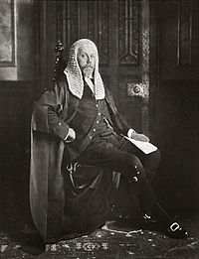
Right Honourable James Lowther (later Viscount Ullswater), Speaker of the House of Commons, 1905 – 1921, presided over the epochal Speaker’s Conference
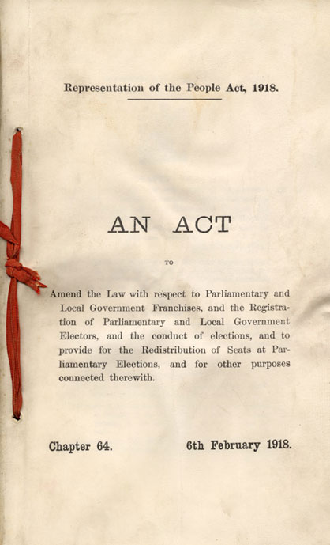
Front page of the 1918 Representation of the People Act
Why was universal male suffrage and the vote for the majority of women achieved in 1918, with WW1 still in progress? Remarkably, this question is rarely given a clear answer - not, at least, an answer which bears scrutiny. This has not prevented sources on the internet making authoritative-sounding statements on the matter. Some may point lamely to women’s war work. But this falls flat even as an explanation for women’s success. More seriously, I hope it is clear by now that it was working class enfranchisement which was the real problem, not votes for women per se. So any answer to the question must address first and foremost how the reluctance to enfranchise working class men came about. Expressed in this manner, the relevance of the war becomes starkly obvious. But let us carefully examine the details.
Make no mistake, the 1918 Act was a radical break from the past, hugely changing the extent of enfranchisement for both men and women. It brought about changes "more comprehensive and far-reaching than any kindred act in English history" (The American Political Science Review, Vol. 12, No. 3 (Aug., 1918), pp. 498-503). This is not mere hyperbole. No previous Act had enfranchised more than two million people; the 1918 Act would enfranchise 14 million.
To pass such a momentous Bill, both Houses of Parliament must have had an equally momentous reason. The reason breaks down into two parts: the reason why it was necessary to re-examine the basis of the franchise at all, and, the reason why it took the form that it did.
The first of these is easy and provides a link with the war which is beyond any doubt. The electoral roll had been shot to pieces by the war. Millions of men were away at war and not able to vote. Meanwhile, back home, the mobilisation of the entire country on a war footing had led to wholesale displacements of people from their home towns and counties. There could be no general election whilst the war persisted, but the ground needed to be prepared to permit an election as soon as possible thereafter. Exactly who could vote – and where – needed to be sorted out. This was why the government was obliged to take on such a major overhaul of the political system when they had more than enough on their plates with World War 1. The need was urgent and imperative, else it would not have been contemplated. This is the first, and indubitable, link between the Act and the war.
According to a near contemporaneous review in The American Political Science Review (Vol. 12, No. 3 (Aug., 1918), pp. 498-503): "It was not by choice that the Ministry and the two Houses turned their attention to electoral questions while the nation was yet fighting for its life, the sound of gunfire within hearing of the Channel ports. Rather, they were compelled to do so by the sheer breakdown of the electoral system, caused by wholesale enlistments in the army and by the further dislocation of population incident to the development of war industries. The situation was bad enough in county, municipal, and parish elections. But a parliamentary election under the new conditions would have been a bald anomaly."
It should not be forgotten that, by the time the 1918 Act was passed, there had been more than seven years since the last general election. The reader will note that this exceeds the maximum term of a British elected government, which is five years. There would not be a general election until the war ended, though they were quick about it when it did. The war ended on 11th November 1918 and the election was held on 14th December 1918, the government being by then of 8 years duration. It is not hard to understand why parliament, and all due process, agreed to these extraordinary arrangements. With millions of men away at the war a general election would have been insupportably undemocratic. (Similar arrangements were in force during the second world war, that government enjoying ten years in office).
The same American Political Science Review cited above opined (writing before an election was ultimately held), "By general consent the life of the Parliament chosen in December, 1910, has been prolonged, in order to defer, and perhaps to avoid altogether, a war-time election. A general election, however, there must eventually be; and whether before or after the cessation of hostilities, it would demand, in all justice, a radically altered system of registration and voting, if not new franchises and other important changes".
With these points in mind, why did the 1918 Act succeed in enfranchising both women and working men when so many earlier attempts to do so had failed, not least as recently as 1910, 1911, 1912 and 1913? You would have to be wilfully blind not to admit the war must be at least part of the reason.
The address the problem of how the franchise was to be resurrected, the Government appointed a committee chaired by the Speaker of the House of Commons, called the Speaker’s Conference. The membership was MPs and Peers. Apart from the chairman, there were 34 other members of the conference: 13 Conservative, 13 Liberal, 4 Irish Home Rulers and 4 representing the Labour Party. It began work in October 1916 meeting twenty-six times and produced a comprehensive set of proposals by January 1917.
I quote again from the near contemporaneous American Political Science Review (Vol. 12, No. 3 (Aug., 1918), pp. 498-503): "Parliament acted wisely.....in entrusting the preliminary consideration of a new electoral law to an extraordinary commission, chosen by the speaker of the house of commons and presided over by him, and constituted with much care to represent in proper proportion not only the parties and groups in Parliament but the various bodies of public opinion on electoral questions throughout the United Kingdom.”
The Speaker, Sir James Lowther, was an anti-suffragist. The 34 members of the Conference were chosen to be 17 pro-suffragist and 17 against. However, when three anti-suffragist members resigned – perhaps sensing the way things were going – the Speaker, despite his own opinions, and to his credit, appointed three new pro-suffragist members. The Conference thus gained a majority in favour of franchise extension.
The report produced by this Speaker's Conference led directly to the drafting of the Bill which would ultimately become the 1918 Act. The recommendations of the Speaker’s Conference were largely adopted in the final Act, the Parliamentary debates changed only some relatively minor details. The extraordinarily egalitarian recommendations of the Conference are summarised by the American Political Science Review as follows, "The effort to adapt electoral machinery to the conditions entailed by the war early convinced the Speaker's Conference that the old practice of defining franchises in terms of relationship to property would have to be discontinued, and that in lieu thereof it would be necessary to adopt the principle that suffrage is a personal right inherent in the individual. In pursuance of this revolutionary decision, the act swept away the entire mass of existing intricate parliamentary franchises and extended the suffrage to all male subjects of the British crown twenty-one years of age or over, and resident for six months in premises in a constituency, without regard to value or kind."
This extraordinarily egalitarian, democratic spirit would appear miraculous were it not for the years of campaigning by both women’s groups and men’s groups, in their disparate ways.
The Speaker’s Conference addressed the male franchise first. The principle of basing the franchise on the democratic basis of a personal right was established in this context . Only then was the issue of women’s suffrage addressed. The door was now open. They voted 15 to 6 in favour of making some sort of concession. In fact the Conference only very narrowly rejected (12 to 10) an equal franchise with men, by 12 to 10. They explicitly did so in order to avoid creating a female majority. Instead they recommended an age restriction of either thirty or thirty-five. In the final Act, the age limit of 30 was adopted. This age restriction will be discussed further shortly. But note that, without it, following WW1, women would have entered the electorate for the first time with an immediate majority of 2 million. As it was, in 1918 they became 43% of the electorate.
The Bill passed its the second reading in the Commons on 23rd May 1917 by 329 votes to 40. On a free vote on 19th June 1917, the Commons approved the women’s clause by 387 to 57 votes. It was subsequently passed by the House of Lords – which had previously been opposed to franchise increases – by 134 to 71 votes. It is generally held that the Lords’ change of heart was due to a reluctance to have a show-down with the Commons. But it reasonable to suppose the conditions of war played a role in their thinking too.

19. Was the 1918 Act a Reward for Returning Heroes?
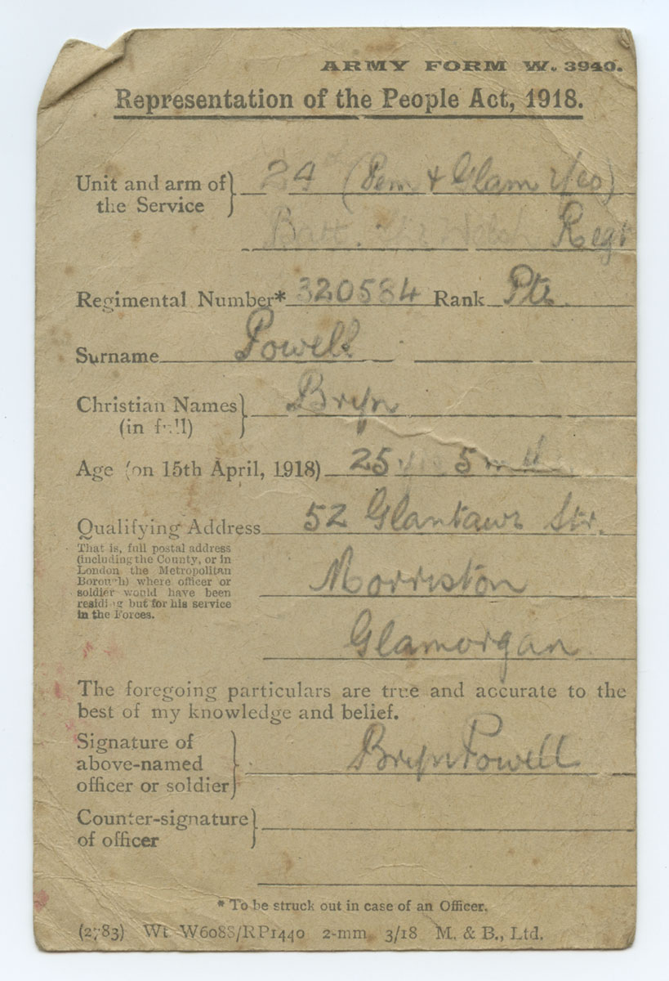
A private soldier’s army form to register on the electorate after the 1918 Act gave him the vote
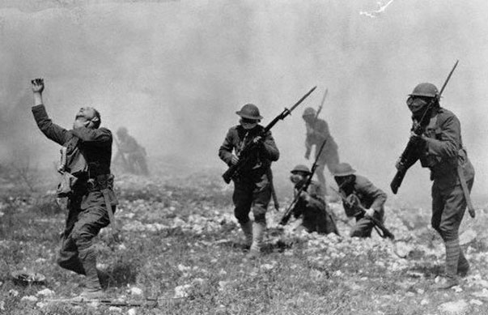
World war one soldiers under chemical attack (this is NOT a re-enactment)
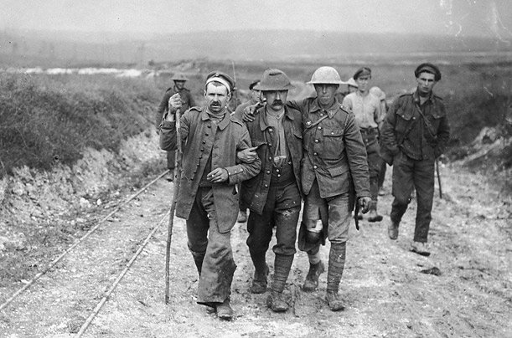
Walking wounded

Was the 1918 Act passed as a reward for the returning heroes?
Essentially, yes.
Although the heroes were not yet returning, the conditions they would meet when they did eventually return was clearly in the minds of parliament. This can be confirmed by reading the Hansard record of the debates on the Bill. There is ample evidence that 'fair play' to the men who would soon return from the trenches was the major motivation.
During the debates in Parliament on the Representation of the People Bill during 1917 there was virtual cross party unanimity on the need to extend the franchise to all men over 21. The Home Secretary, George Cave (Conservative) introduced the Bill as follows:
"War by all classes of our countrymen has brought us nearer together, has opened men’s eyes, and removed misunderstandings on all sides. It has made it, I think, impossible that ever again, at all events in the lifetime of the present generation, there should be a revival of the old class feeling which was responsible for so much, and, among other things, for the exclusion for a period, of so many of our population from the class of electors. I think I need say no more to justify this extension of the franchise."
So there we have it. The principle purpose for the 1918 Act was the need to dissolve the previous class-based franchise - and the specific motivation was the recognition that "If they are fit to fight they are fit to vote". That is an actual quote from the Hansard record, uttered by William Thorne, member for West Ham South.
The primary motivation for the 1918 Act was men. The former opposition to the enfranchisement of working class men had evaporated as a result of the war. The debt owed to the soldiers and sailors is readily appreciated. But once the vote is given to these men, the entire class basis of the franchise collapses. That the extension of the franchise could not be confined merely to ex-servicemen was argued forcefully by the Prime Minister, Lloyd George. A few extracts of his speech from the Hansard record suffice to drive the point home.
“If you were to create a new, or what I may call a military and naval franchise - that is, that a special right to vote be granted to those gallant men who are serving their country on sea and land in all parts of the world, - you would have to give a voice to all the other men. Take the munition workers. They have left their homes at the invitation of the State in large numbers; they have severed their old family ties and their old residential ties, and have gone into places hitherto unknown to them, and crowded there in enormous numbers, and I do not hesitate to say that, after the appeals addressed to them on behalf of the Government and the State, they are rendering equally important and effective service in the conduct of the War as are our soldiers and sailors.”
And again,
“My hon. and learned Friend mentioned the sailors and the mine-sweepers. Their perils are great and incalculable. Of course, they have the same claim as even our gallant soldiers, whether they are sailors of the mercantile marine or sailors in the Navy; but that is not the end of it. Come to our miners and our munition workers. What is the position there? They are not in the mines, instead of being in the trenches, of their own choice—a very considerable number of them. What happened? When you had voluntary recruiting in this country, because the mines had been depleted and because the great engineering works had been depleted, we had practically to warn the recruiting officers on these places, and we had to make an appeal to them not to recruit, otherwise hundreds of thousands of them would have gone to the front. As a matter of fact, hundreds of thousands were going. It was becoming a serious matter. The first thing I had to do, as Minister of Munitions, was to appeal to Lord Kitchener to use all his power to get back men who had already gone. Otherwise, our engineering works would have been crippled. How unfair to say to them, ‘If you had only volunteered, if you had only fought! It is true you are rendering greater services where you are, and that you remained where you are at the request of your country because you are serving your country better there, but we cannot recognise that. Therefore, we refuse you the vote.’ That is absolutely indefensible.”
And here is Lloyd George again, expressing clearly how different the world was going to be after the war, and how it was no longer right to exclude those men who would be forging this new world,
“We were confronted with the fact that we had a stale register. It is the War that has put us in this position. It is common ground that by some means or other you must bring that register up to date. The whole point is, what is that register going to be? We attempted, first of all, to deal with it on the basis of merely a Registration Bill. Every effort-was made to eliminate anything in the nature of a franchise proposal. Why? Because we were afraid of provoking controversy. We found it impossible. The moment it was introduced on the floor of the House both parties started condemning our proposal on the ground that you were excluding men who had an absolute right to pronounce upon the kind of settlement you are going to make in England after the War. There are two reasons why you cannot merely have a renewal of the old register. The first is this. The War has forced us to confront questions; the War has compelled us to decide questions practically in a single Parliament after the determination of the War which in the ordinary course might have taken a generation to settle. There is no doubt that the Parliament that is elected after peace is the Parliament which will have-to settle questions which will practically determine the course of things, not merely in Great Britain and in the British Empire, but very largely throughout the world for generations to come.
The trade of this country, the industries of this country, the relations of capital and labour in this country, the relations—and this is very important in reference to one of the recommendations of Mr. Speaker's Conference—of one class of labour to another class of labour, questions of the conditions of life in this country, the health of the people, the housing of the people, the education of the people, the relations of this country to the whole Empire, and the relations of the Empire to the rest of the world. These are gigantic problems which will have to be settled by the Parliament which is elected on this register. You cannot have the old register. Why? Because by taking the old register you would be excluding the men that had made the new Britain possible.”
Those were the words of Lloyd George. I trust that’s clear now. The primary purpose of the 1918 Act was to enfranchise working class men, and this came about as a direct consequence of the war.
[Quotes from Lloyd George from,
Hansard 14th August 1916 (vol 85) para 1451, http://hansard.millbanksystems.com/commons/1916/aug/14/parliament-and-local-elections#column_1451
Hansard 28th March 1917 (vol 92) paras 487-489, http://hansard.millbanksystems.com/commons/1917/mar/28/mr-speakers-services#column_487 ]

20. Was the 1918 Act a Result of the Suffragette Protests?
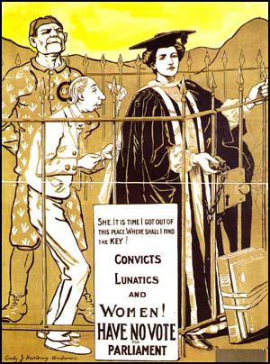
Hmm…methinks that cage should be full of working men, too

Was the bill passed due to the Suffragette protests? Emphatically not. It should be clear from the history I have related that, as the suffragette activity increased following the defeat of the second Conciliation Bill in 1911, so their influence on the political process decreased in proportion. When Emmeline and Christabel Pankhurst ceased their suffrage campaigning, ostensibly in favour of the war effort, they had become irrelevant. The passing of the 1918 Act was more than three years after they had ceased campaigning. This alone hardly suggests their relevance. In any case, with the war on, Parliament had much more pressing concerns than worrying over a protest movement that was more than three years past its zenith.
Before suspending their campaign, and when the suffragette activities were at their height in the last few years before the war, the Pankhursts had managed to alienate the public, alienate much of their potential support in Parliament, and alienate most of the rest of the suffrage movement. Here’s a quote by Marcie Kligman from a Welsh Communist website, The Effect of Militancy In the British Suffragette Movement (1996),
"These actions by the WSPU, while attracting huge amounts of publicity, had the opposite effect intended; the public began to disapprove of the suffragettes, as well as their cause. While most people, before the outbreak of rampant militancy, supported the cause of women's suffrage, once the new actions started, began to disapprove. Opponents of women's suffrage in Parliament used the terrorist actions the women were using to their advantage in debate, citing the insane actions as a very good reason why women should not get the vote. Parliament and the suffragettes thus reached a stalemate. The more militant the WSPU became, the more reluctant Parliament was to grant women the vote, and the more firmly Parliament stood on the issue of suffrage, the more violent and desperate the suffragettes became."
The only direct reference to the suffragettes in the 1917 Hansard record of the extensive debates prior to the 1918 Act being passed was this, from 28 March 1917, paragraph 470:
"And let me add that, since the War began, now nearly three years ago, we have had no recurrence of that detestable campaign which disfigured the annals of political agitation in this country, and no one can now contend that we are yielding to violence what we refused to concede to argument."
This was spoken by Mr Asquith, the man who, as Prime Minister in 1916, prepared the ground for the 1918 Act by commissioning the Speaker's Conference and supporting its recommendations. He is stating clearly here that his change of heart, having previously opposed women's enfranchisement but now supporting it, was in part due to the cessation of the suffragettes acts of violence and criminal damage.
Of course, no MP was going to stand up in the House and suggest that they should give in to pressure. But the strength of feeling against the suffragettes' actions, not just in parliament but in the public at large, and even within the ranks of the moderate suffragist movement, should not be under-estimated. Evidence of the destructive influence of the suffragettes' violent acts are as follows. Firstly, from Lloyd George,
- "The action of the Militants is ruinous. The feeling amongst sympathisers of the cause in the House [of Commons] is one of panic. I am frankly not very hopeful of success if these tactics are persisted in." (Letter from Lloyd George to CP Scott, 29 November 1909).
- "Haven’t the Suffragettes the sense to see that the very worst way of campaigning for the vote is to try and intimidate a man into giving them what he would gladly give otherwise?" (Lloyd George, speaking in 1913).
However, what one must concede is that the suffragettes did assist in putting women's enfranchisement on the agenda. Women would certainly not have got the vote if men had not known that they wanted it. But the suffragettes' violent actions were unnecessary. The Constitutionalist suffragists' more moderate approach would have been sufficient.
However, neither the suffragettes nor the female Constitutionalist suffragists caused the 1918 Act to be enacted when, and in the manner that, it was.

21. Why were women included in the 1918 Act?
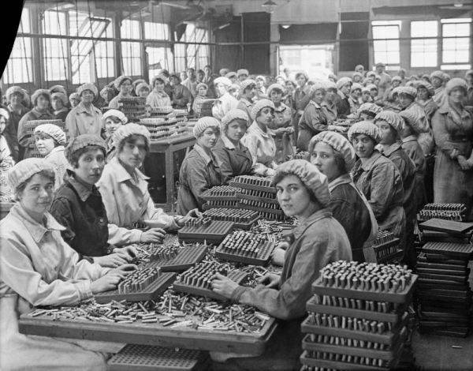
Women munitions workers
Why was the 1918 Act passed when it was, with the war still raging? The answer is twofold. Firstly, the Act became necessary to revivify the electoral roll which had been completely trashed by the war. Secondly, there was broad cross-party support that the vote could no longer be withheld from the gallant men away at war, so many of which had given their lives or their limbs for their country. Both these causes are beyond doubt, as is made clear from the Hansard records, such as the Lloyd George speech quoted previously. “If they are fit to fight, they are fit to vote” was the prevailing sentiment.
Both these reasons for passing such an Act at that time relate to the war and to men. The matter is absolutely clear, however much some sources may attempt to elide the issue. The reason for the 1918 Act being passed when it was related to men, not women. Moreover, it would be preposterous to assert that the war was unimportant to its timing. Both the above reasons relate crucially to the war.
So, why were women also enfranchised in the same Act? Firstly let us demolish the oft-repeated idea that this was a reward for women’s war work. There is some excuse for believing that women’s war work caused a change of heart in MPs who previously voted against Bills to enfranchise them – not least the Hansard record. But these are politicians of which we speak. They must needs give a credible sounding explanation for their change of mind. But, in truth, the majority had been in favour of female suffrage all along. The history of successive failures to pass Bills to that end is explained by the Big Snag – the priority they gave to protecting their Party’s electoral position. The Big Snag was now defeated since the offering in the 1918 Bill included universal male suffrage. Female suffrage could now be adopted in safety, and women’s war work provided a convenient rationalisation.
Holton agrees. She writes,
“Women’s war work may have helped persuade some (MPs) but, perhaps more likely is that it provided others with a face-saving excuse to alter their positions”.
And also, in the context of women munitions workers,
“Many, like the women’s suffragist’s former arch-enemy, Asquith, used such developments to explain their change of heart on votes for women”.
There are a whole battery of reasons why women’s war work does not cut it as an explanation.
Firstly, if the vote for women was to be a reward for female munitions workers it rather kissed its target. Being mostly under 30 year old, these were the very women who remained excluded.
Secondly, women’s war work was work which would have been done by men in peace time. But working men had been doing this work forever, without receiving the vote. How then can one consistently argue that such work was a route to becoming enfranchised? Clearly it was not. And, you will forgive my cynicism, governments are not noted for their generosity in rewarding past favours - especially those provided by manual workers.
Finally, consider women in France. They did just as much war work but failed to receive the vote after the war.
So, why were women enfranchised in the same 1918 Act? Some have put forward the suggestion that the electoral changes were a ruse to acquire increased tax revenue (by increasing the number of tax payers) to help pay off war debts. However, I have been unable to find any evidence to support the idea. Moreover, since the most significant change to the franchise was to eliminate the property requirements, the link to taxation was, at least initially, weakened not strengthened. I must pass over this rather cynical suggestion.
The reason why women received the vote alongside working men, in the same 1918 Act was simply that there was no longer any reason why not. It’s that simple. Recall that even Mrs Pankhurst recognised that there had been majority Parliamentary support for female enfranchisement since at least 1885. The correct question, therefore, is not why were women enfranchised in 1918 but why they had not been enfranchised earlier? The answer to this is the Big Snag. With the Big Snag unsnagged by the wave of democratic sentiment due to the war, with the harder task of enfranchising working men now accomplished, the vote for women simply followed as a virtually automatic consequence.
In short, women got the vote in 1918 as a collateral effect of working men getting the vote, which in turn resulted from the war.
If you forget that the 1918 Act was really about giving working class men the vote, you will inevitably misunderstand the reason that women got the vote - and perhaps even commit the folly of thinking it was something to do with the Pankhursts.

22. Why the age limit of 30 in the 1918 Act?
Some people get terribly exercised about the 30 year age limit for women in the 1918 Act. It is inappropriate. It was obviously inevitable that this would be a short term measure given that the democratic principle of a vote by right had been established. The reason for the limitation was simply to avoid women being introduced into the franchise for the first time and entering as a clear majority. Women would have been in the majority by two million if they had received the vote in 1918 at 21 like men.
The Speaker explained in the House of Commons [4 April 1919] that:
It was thought desirable that women and men should be somewhere about on a parity and we took the age of thirty which was the nearest we could get to make the number of women voters equal to the number of men.
As it turned out, the 30 year limit made women 43% of the electorate in 1918.
It is thought probable that the women’s suffragist organisations gave their blessing to the 30 year age limit during the deliberations of the Speaker’s Conference. The Constitutionalist suffrage organisations were active in lobbying the Conference, having the sense to realise this was their big chance.
The route which Millicent Fawcett took to influencing the Speaker's Conference was via Lady Shelborne of the Conservative and Unionist Women's Franchise Association - by whose mediation she influenced William Bull, a Conservative member of the Conference....because "it would have a better chance of being carried than anything proposed by a Liberal member".
This period saw Fawcett revealed as a canny back-room negotiator. She was sensible enough to want to avoid jeopardising the best chance women had had by over-playing her hand and going for full adult suffrage on equal terms with men.
As far as I am aware there is no documentary proof that Fawcett herself suggested the age restriction of 30 for women - but the suffragist lobbying of the Conference "would appear to have put forward the idea of an age restriction on the women's vote as the most preferable form of limitation". In other words, a vote for women on the same basis as men, with the implication of massive numerical dominance by women, was accepted by the female suffragist realists as a non-starter - and so the women's lobby itself suggested their preferred compromise position. It may well have been Fawcett personally, since she was the dominant player.
In any case, all women got the vote, on the same basis as men, at age 21, in the following 1928 Act.
Consequently, there was only a ten year period in the whole of history in which all adult men over 21 had the vote and men were the majority of the electorate. Women have been the majority of the electorate in the UK by about a million since 1928.

23. Was the 1918 Act passed to avoid revolution?
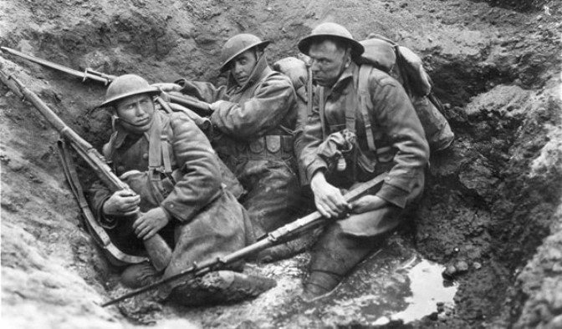
World war one soldiers in a shell crater, caught between sinking in mud and enemy fire
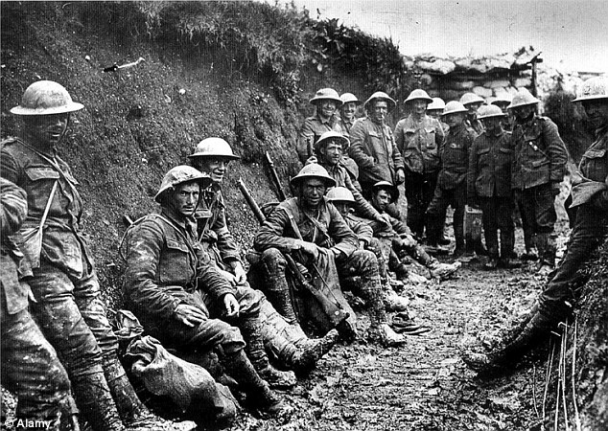
World war one soldiers in trench
Just how spooked was the political establishment of Britain by the Russian revolution in 1917?
The British Establishment had been preconditioned to be twitchy about the prospect of revolution in Britain by the Great Unrest of 1910 – 1914. Widespread strike actions, in many cases in defiance of their national leaders, had demonstrated working class militancy. It was the breadth and spontaneity of these actions that shook the political establishment to the core. Combining concession with coercion, the government had been forced to deploy troops against striking workers on several occasions. Union leaders struggled to regain authority and control. Thus, over the immediate pre-war period, Bolshie working class men had been giving the establishment a major headache.
On top of this, the pre-war government had been beset with the crisis looming over potential civil war in Ireland and mutiny at the top of the armed forces over Home Rule.
Then, while the Speaker's Conference was deliberating its policy recommendations, along comes the Russian revolution against this pre-war backdrop of leftist militancy and insurrection. The timeline was as follows,
- In October 1916 the Speaker's Conference was formed
- In March 1917 the first Russian revolution occurs. This took place in the context of heavy military setbacks during WW1 which left much of the Russian army in a state of mutiny.
- In June 1917 the Representation of the People Act was passed in the Commons by a massive majority of 385 to 55.
- In November 1917 the second (Bolshevik) Russian revolution led by Lenin occurs.
- In February 1918 the Representation of the People Act (1918) becomes law, having also passed through the House of Lords with another huge majority of 134 to 71.
Note that the Russian revolution started in the ranks of the army.
Would the British government have been in a state of high anxiety over the possibility of revolution as a result of the Russian experience coupled with the background of the Great Unrest? If so, this would have provided a possible motivation for the enfranchisement of working class men. One might argue that the government feared giving working-class men a political voice, but feared the consequences of not doing so even more. To give them the vote was, perhaps, an attempt to defuse an inflammatory situation.
The temptation to think this way is increased by the apparent impact of the French revolution on the Great Reform Act of 1832, and the potential relevance of the American Civil War, and perhaps Garibaldi’s adventures in Sicily, on the 1867 Reform Act.
However, tempting though it may be to contemplate such link, I doubt this interpretation of history. I have examined the contemporary Hansard records and found no evidence in favour of it. (In the debates on the Representation of the People Bill, one un-named member shouted out “what about the Russian revolution!”, but that’s its only mention). On the contrary, and to my surprise, in 1917 the reaction of the UK parliament to the Russian Revolution seems to have been congratulatory.
I had forgotten just how suspicious parliament was of the Czar, particularly in his foreign policies. Quite simply, the UK parliament initially regarded the revolution in Russia as having got rid of a problem ruler. In time to come, of course, they would cease to regard the Bolshevik government in Russia as being such a blessing. But all that is pertinent to our purposes is the view prevailing in 1917. I found no direct evidence in this period of concern regarding the spreading of revolutionary fervour to the British working man.
Nevertheless, I retain this hypothesis here as a background possibility. That I have found no explicit evidence for it in Hansard may be misleading. Sometimes politicians are coy about their true motivation. Perhaps it was just not done to mention potential revolution in the House. Perhaps discussion of such things was confined to the bars of Westminster, and would not appear in Hansard. I don't know.

24. If WW1 Had Not Happened, Would Universal Suffrage Have Occurred Anyway?
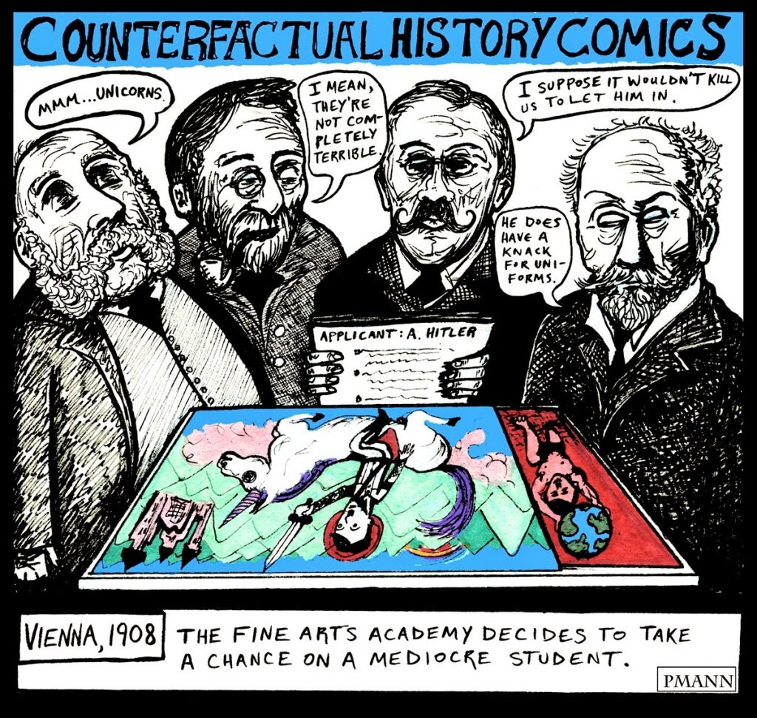
Counterfactual History – it’s pointless speculation
If the war had not intervened, would a major Reform Act, including some measure of female suffrage, have been passed in any case? It is impossible to say with certainty. One must accept that the progress of human affairs is chaotic, in the strict mathematical sense of being unpredictable. The very occurrence of the war is testament to that. So, if the war had not happened, who’s to say what other occurrences might have either precipitated or prevented a similar Reform Act?
The NUWSS strategy was to put female suffrage on the Liberal agenda for the next general election. Holton opines that, in view of the fact that negotiations between the suffragists and the Government were taking place just two weeks before the outbreak of war, there is every reason to suppose that it would have been. But Asquith and Lloyd George had slipped out of such political nooses before and might well have done so again. They clearly had concerns regarding attempting to defeat The Big Snag by jumping either way. Indefinite delay had been their policy thus far.
Moreover, militancy was still a barrier to progress. And this no longer meant just the WSPU. Dissident militant groups had recently broken away from the WSPU due to their desire to pursue universal suffrage. These included the East London Federation and the United Suffragists. The only Pankhurst left as a serious contender in the game was thus Sylvia, who led the East London group. It was she, together with George Lansbury, with whom the Government had been negotiating so close to the war. But claims that she was about to throw in her lot with the Constitutionalists are unproven. The Government’s ‘negotiations’ with her might equally well have been an attempt to gain intelligence about the likely development of serious male-led militancy by syndicalist workers. Recall that the Great Unrest was the backdrop here.
The Constitutionalists, even some of the Marxist elements, were worried about this tendency towards violent revolution. Holton quotes Catherine Marshall’s perspective as follows,
“The great mission awaiting women is to help keep the great revolution which is coming on sane and human lines. I believe women will have no small voice in determining the manner in which that revolution is brought about.”
She declared that she was, “disturbed by the growing links becoming apparent between sections of the suffrage movement and revolutionary socialist groups.”
And she expressed the concern that, “the women, instead of having a steadying influence in the social upheaval that is coming, will have the opposite effect, reinforcing all that is most violent and uncontrolled and bitter….I think the prospect is rapidly becoming very serious”.
These fears were not unfounded. Sylvia Pankhurst’s East London Federation was closely associated with the Daily Herald League who had grown disillusioned with mainstream political methods and had adopted syndicalism as their preferred means of achieving socialism. Recall this means anarchy and violence. Here’s another extract from Holton,
“In the East End, Sylvia Pankhurst successfully escaped re-arrest under the protection of ‘Kosher Hunt’, a noted prize-fighter of the district. Militant demonstrations in this area now included large numbers of men; many demonstrators carried sticks to parry police truncheons, and others made use of a ‘Saturday-Night’ of knotted rope. Sylvia Pankhurst recalled ‘I saw that the police now shrank from attacking us in the East End; I wanted that shrinking accentuated. A ‘People’s Army’ began to drill, committed to full adult suffrage, and intended to defend participants in a projected rent strike”.
The Marxist/communist/syndicalist nature of the militant wing of the merging male and female interests were noted by George Lansbury. He recalled a meeting which included many of the dissident militants who “all wore red caps” and who had been likened in the press to “Miss Defarge and her knitting”.
One could take a cynical view that WW1 came along conveniently in time for the British establishment to dispatch the Bolshie element abroad to the trenches. Be that as it may, these observations emphasise how fragile would be any attempt to address the counterfactual “what would have happened if WW1 hadn’t?”. Had male-led, hence dangerous, militancy expanded until the tutelage of Tom Mann and Sylvia Pankhurst, the British establishment would undoubtedly have suppressed it with military force. While the British heyday of crushing seditious uprisings in the colonies were some years passed, they still had the capacity and will so to do. I make these remarks only to demonstrate that alternative histories can only ever be fictions.
Nevertheless, there is a strong case that the momentum was now behind universal adult suffrage. One could argue that it was only a matter of time. But one could have argued that at any time since 1884, and here they were 30 years later, no further forward. Who’s to say that universal suffrage might not have taken another 30 years had WW1 not intervened? Unlikely, perhaps, but suppose Lloyd George had proved sneaky enough to delay the matter. He was followed by a Conservative Government. They would not have put forward a universal suffrage Bill, but they might have passed a Bill for limited suffrage of ‘respectable’ women, along the lines that Mrs Pankhurst had favoured. Who knows, if these new women voters had proved to be predominantly Tory or Liberal voters, they may subsequently have kept Ramsay MacDonald out of office. In that case we may have arrived at the 1939-45 war with the working class, of both sexes, still not enfranchise. Please don’t shout that if WW1 had not happened then probably WW2 would not have happened either. I know. I don’t mean any of this wild speculation to be taken seriously except as a refutation of the suggestion that one could deduce what would have happened had WW1 not happened. We just couldn’t.
What we do know is that WW1 did happen, and the 1918 Representation of the People Act was conceived and passed during the execution of that conflict and for reasons intimately associated with that conflict.

25. Summary and Conclusion

Centuries of oppression there were, but it was oppression of the many by the few, not oppression of women by men. And the many were of both sexes, and the few were of both sexes.
Prior to the nineteenth century only around 2% of the adult male population could vote. The right to a parliamentary vote was dependent upon property. All but a few men were too poor to have the vote. Men had fought for the vote sporadically for centuries, but with no success until just before the Victorian era.
On an historical timeframe, men barely got the vote very much before women – as the graph shows clearly. Jeremy Bentham argued for women’s suffrage as early as 1817 when only about 4% of adult men had the vote. And the campaigning for female suffrage intensified prior to 1867, thanks to John Stuart Mill, at a time when still only about 12% of adult men had the vote. By 1884, when the proportion of adult men with the vote reached just 56%, there was already a majority of MPs supportive of female suffrage in some form.
Emmeline and Christabel Pankhurst and their suffragettes did not bring about the enfranchisement of women. The non-militant women’s suffragists were far more influential. The suffragettes' aim was gender-specific and class-specific: "votes for women on the same terms as the existing franchise for men". They did not recognise the equal rights of working class men who were also largely disenfranchised. The larger, Constitutionalist, wing of the female suffragist movement finally achieved an alliance with the working men’s claim, via the Labour Party and the Trade Unions. Had the war not intervened, this alliance was, in fact, the only approach which could have succeeded.
The perspective on universal suffrage that emphasises a male hegemony suppressing the rights of women is a serious distortion of historical reality. The truth is that the struggle for universal suffrage was the working class struggle, not primarily a gender issue. The historical Big Picture is that the enfranchisement of men and women was a single process.
By far the most significant Act in the history of extending the franchise was the 1918 Representation of the People Act. This brought 14 million people onto the electoral register (5.5 million men and 8.5 million women). No previous Act had enfranchised more than 2 million. Moreover, the 1918 Act was the first time that the principle of democracy had triumphed, the vote being recognised as a right rather than being tied to wealth or property.
That no women were enfranchised before 1918, despite a majority of MPs having been in favour for over 30 years, was due to the Big Snag. Any attempt to give the vote only to ‘upper crust’ women, as Mrs Pankhurst wished, threatened the ruling Liberal Party’s electoral chances since it was assumed that such women would primarily increase the Conservative vote. This problem could, in principle, be avoided by simultaneously enfranchising the working class. But there was even greater Parliamentary reluctance to give the vote to working men. This was the Big Snag – that votes for women – any women – required the vote to be given to working men first. This made the issue far more problematic because it required a change of mindset. It required a democratic mindset. It is hard for us now to understand that democracy had, until 1918, been regarded as a dangerously radical notion.
I hope my history has made it clear that the 1918 Representation of the People Act was primarily about the enfranchisement of working class men. The first World War was crucially instrumental in the change of heart which permitted the democratic principle to triumph. The old class based sentiments which had kept working class men disenfranchised were ameliorated by the horrors of the WW1 trenches and the recognition by the Establishment of the country’s indebtedness to working men.
The 1918 Act was not primarily about the enfranchisement of women. Rather, women received the vote in the same Act simply because the barrier to their enfranchisement, that of working men, had been removed. Women got the vote as a collateral consequence of working men getting the vote.
If you forget that the 1918 Act was really about giving working class men the vote, you will inevitably misunderstand the reason that women got the vote - and perhaps even commit the folly of thinking it was something to do with the Pankhursts.
Since WW1 played a crucial role in working men, and hence women, being enfranchised, one might say that women’s vote owes more to the Kaiser than to the Pankhursts.
Any speculation as to what might have happened had the war not intervened is ultimately meaningless. The fact is that the slaughter in the trenches gave birth to a new mood of egalitarianism in Parliament, sweeping away the old class based objections to enfranchising working class men. Consequently, one could say that the vote for working class men – and hence the vote for women - were bought with men's lives. It is understandable that the popular historical narrative has sought to draw a veil over this ugly truth. Indeed, it may be best to allow celebrations of the achievement of democracy to triumph over the manner of its attainment.
But not entirely. The truth must not be buried. And this is the reason for my writing of this history. My fear is that the celebrations which are due in February 2018 will bury the truth still further. And even if the fact that working men were enfranchised by the 1918 Act cannot be supressed, the reason for it might well be subject to further false mythologizing. As an example, consider this preposterous remark, made in Parliament on International Women’s Day on 8th March 2016 by Madeleine Moon, MP for Bridgend,
Everyone knows that women were given the vote at the end of the 1914-18 war, but that cloaked the fact that working-class men were also given the vote. Does the hon. Lady, like me, celebrate the fact that women, through their campaigning, also led to those men accessing the vote? That should never be forgotten.
https://hansard.digiminster.com/Commons/2016-03-08/debates/16030861000001/InternationalWomen’SDay2016#contribution-EE367C30-1C7D-4F14-A204-E441FAAB3912
Are we to have Mrs Pankhurst lauded as winning the vote for men now? Is this ignorance? Or is it a deliberate re-writing of the history that has already been so traduced in the public mind?
The prevailing myth that the vote for women resulted from triumphing over male hegemony has been exposed as a monstrous perversion of reality; an untruth which has persisted for a century and must now be discarded. The truth is that universal suffrage for both sexes was pioneered by men, and paid for, over many centuries, by vast numbers of men’s deaths.

